“Are You Enough for Me?”: The Effects of Variety Seeking and Product Attachment on the Brand Investment Model
Hye-Shin Kim (University of Delaware) and Eunjoo Cho (University of Arkansas)
Keywords: Variety, investment, product attachment
Conceptual Framework and Hypotheses. The investment paradigm of interpersonal relationship (Rusbult & Buunk, 1993) explains that attractiveness of alternatives, satisfaction, and investment of resources determine individuals’ commitment to the relationship. Less attractive brand alternatives and greater satisfaction and investment in brands significantly increase consumers’ commitment to the relationship with brands (Sung & Choi, 2010). For fashion related purchases, consumers' need for variety and their emotional bond with the product category significantly informs their shopping behavior. By integrating these two fundamental consumer motivations within the investment model, this study further expands the literature and offers insight into consumer tendencies to be brand loyal and invest in fashion brands
Consumers are often left with the question of whether to buy fashion products from their favorite brands or search for new brands. If consumers are motivated to diversify their choices across products and brands, they tend to try out new brands to meet internal needs for stimulation (Raju, 1980). Whereas some research confirms individuals’ tendency to seek variety (e.g., Rubio et al., 2019), other research discusses that consumers consistently maintain their preferences for particular brands (Jones & Sasser, 1995). The consistency seeking behavior is driven by an emotional connection between consumers and brands (Johnson et al., 2006). This implies that consumers’ likelihood to keep purchasing favorite brands depends on their feelings toward products and brands. The strong emotional bond toward products is described as product attachment. Individuals develop attachments to products that have special meanings and/or memories (Schifferstein & Zwartkruis-Pelgrim, 2008). Because these two distinct motivations (i.e., variety seeking and product attachment) can influence consumers’ product choice in a different way (Fishbach et al., 2011), it is important to examine how they influence the three determinants of commitment to the consumer-brand relationship. The purpose of this study is to develop and test a model that investigates the impact of variety seeking and product attachment on attractiveness of alternatives, satisfaction, and investment of resources. Figure 1 shows the study hypotheses. H1a, H1b, H2a, and H2b examine the effects of consumer motivations (need for variety and attractiveness of alternative brands) on two components of the investment model (attractiveness of alternative brands and satisfaction with frequently purchased fashion brands). H3, H4, and H5 examines the relationships of the three components of the investment model.
Methods and Results. 242 female participants were recruited from Amazon’s Mechanical Turk (MTurk) for a nominal payment. The participants were U.S. citizens (98%), white (79%), and 25-64 years old (88%). Most had at least some college credit (93%) and 64% had a Bachelor’s or higher degree. Participants were asked to list fashion brands that they most frequently purchase when shopping for fashion or related products. Next, they were asked to think of “the list of frequently purchased brands” when answering questions in the survey which included the level of satisfaction with frequently purchased brands (Picon et al., 2014), attractiveness of alternative brands (Picon et al., 2014), and investment in frequently purchased brands (De Wulf et al., 2001). Also measured were their need for variety seeking (Baumgartner & Steenkamp, 1996) and personal attachment to fashion and related products (Schifferstein & Zwartkruis-Pelgrim, 2008). Confirmatory factor analysis (CFA) validated the measurement of the five constructs in the hypotheses; fit indices (PCMIN/DF=1.761; TLI=.961; RMSEA=.056; CFI=.968; SRMR=.077), significant factor loadings (.602 to .957), composite reliability (CR>0.7), convergent validity (AV>.5), and discriminant validity (MSV<AVE) were all acceptable. Cronbach’s alphas for constructs ranged from .80 to .97.
Structural equation modeling using AMOS tested the hypothesized model. Goodness of fit indices indicated a weak model fit (PCMIN/DF=2.403; TLI=.928; SRMR= RMSEA=.076; CFI=.939; SRMR=.1387). The model was improved by adding two paths Product Attachment → Investment in Frequently Purchased Brands (Path A) and Need for Variety → Investment in Frequently Purchased Brands (Path B). Fit indices were good (PCMIN/DF=1.761; TLI=.961; RMSEA=.056; CFI=.968; SRMR=.065). H1a, H1b, H3, and H5 were accepted. H2a, H2b, and H4 were rejected. The two new added paths (Path A and Path B) were significant.
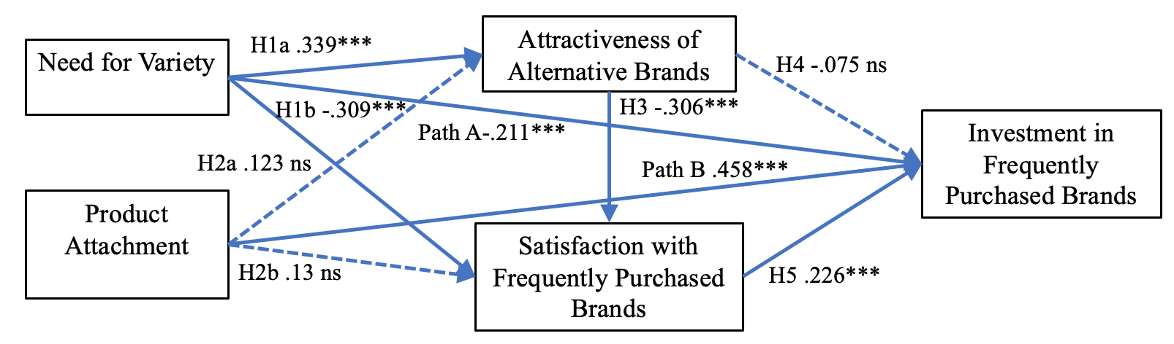
Figure 1. Standardized estimates of hypothesized paths in the modified model.
Discussion. Consumer need for variety is fundamental to brand investment (H1a, H1b, Path A). The study data shows solid evidence that in fashion products, consumer need for variety positively influences perceived attractiveness of alternative brands but negatively affects consumer satisfaction with and investment in their most frequently purchased brands. This result is a strong example of how consumers need for variety and “other products” negatively influences their existing relationship with favored brands. From a consumer-brand relationship perspective, consumers’ need for and tendency to seek a variety of products weakens their relationship with favored brands. Consumer’s emotional attachment to fashion products did not make them feel more attracted to other brands or even more satisfied with their favored ones (H2a, H2b). Consumer attachment to products did not influence consumer’s attitudinal and evaluative aspects of brand investment but directly influenced their level of investment in their favored brands (see Path B). Finally, attractiveness of alternative brands influenced satisfaction with frequently purchased brands (H3) but it did not directly influence brand investment (H4). Causal relationships assumed in the model should be interpreted with care. Brands need to seek strategies to satisfy consumer needs for variety and sustain consumer investment within their brand. Further research is warranted on how consumer attachment to fashion products can be leveraged to encourage brand investment.
References
Bansal, H. S., Taylor, S. F., & St. James, Y. (2005). “Migrating” to new service providers: toward a unifying framework of consumers’ switching behaviors. Journal of the Academy of Marketing Science, 33(1), 96-115.
Baumgartner, H., & Steenkamp, J. E. M. (1996). Exploratory consumer buying behavior: Conceptualization and measurement. International Journal of Research in Marketing, 13(2), 121-137.
De Wulf, K., Odekerken-Schroder, G., & Lacobucci, D. (2001). Investments in consumer relationships: A cross-country and cross-industry exploration. Journal of Marketing, 65(4), 33-50.
Fishbach, A., Ratner, R. K., & Zhang, Y. (2011). Inherently loyal or easily bored?: Nonconscious activation of consistency versus variety-seeking behavior. Journal of Consumer Psychology, 21(1), 38-48.
Johnson, M. D., Herrmann, A., & Huber, F. (2006). The evolution of loyalty intentions. Journal of Marketing, 70, 122-132.
Jones, T. O., & Sasser, W. E., Jr. (1995). Why satisfied customers defect. Harvard Business Review, 73, 88-100.
Picón, A., Castro, I., & Roldán, J.,L. (2014). The relationship between satisfaction and loyalty: A mediator analysis. Journal of Business Research, 67(5), 746-751.
Raju, P. S. (1980). Optimum stimulation level: Its relationship to personality, demographics, and exploratory behavior. Journal of consumer research, 7(3), 272-282.
Rubio, N., Villaseñor, N., & Yagüe, M. J. (2019). Customer’s loyalty and trial intentions within the retailer: the moderating role of variety-seeking tendency. Journal of Consumer Marketing, 36(5), 620-632.
Rusbult, C. E., & Buunk, B. P. (1993). Commitment processes in close relationships: An interdependence analysis. Journal of social and personal relationships, 10(2), 175-204.
Schifferstein, H.N.J. and Zwartkruis-Pelgrim, E.P.H. (2008). Consumer-product attachment: Measurement and design implications, International Journal of Design, 2(3), 1-14.
Sung, Y., & Choi, S. M. (2010). “I won't leave you although you disappoint me”: The interplay between satisfaction, investment, and alternatives in determining consumer–brand relationship commitment. Psychology & Marketing, 27(11), 1050-1073.

