This is Where a Title Will Go (title header, bold, 20 pt font, Times New Roman)
This is Where a Subtitle Would Go, If You Have One (subtitle heading, italic, 15 pt font)
Author Name, Job Title, Institution, City, State Abbreviation, Country
Ophelia E. Redwood, Professor of OER, The OER Institute, Atlanta, GA, USA
[add additional authors as needed]

Abstract (level 1 header, bold, 16 pt font, Times New Roman)
Your abstract should be no more than 250 words in length. This sample abstract text is 198 words. The abstract text will go here. This is sample abstract text that is copied over and over again. Your abstract should be no more than 250 words in length. This sample abstract text is 198 words. The abstract text will go here. This is sample abstract text that is copied over and over again. Your abstract should be no more than 250 words in length. This sample abstract text is 198 words. The abstract text will go here. This is sample abstract text that is copied over and over again. Your abstract should be no more than 250 words in length. This sample abstract text is 198 words. The abstract text will go here. This is sample abstract text that is copied over and over again. Your abstract should be no more than 250 words in length. This sample abstract text is 198 words. The abstract text will go here. This is sample abstract text that is copied over and over again. Your abstract should be no more than 250 words in length. This sample abstract text is 198 words.

Keywords: (up to 5, level 2 header, bold, 14 pt font, Times New Roman)
Keyword One, Keyword Two, Keyword Three, Keyword Four, Keyword Five

[Directions to authors: Do not adjust the header and footer, except to add the corresponding author’s email address. Do not adjust the margins. Your article should start on a fresh page, no matter where the title, authors, abstract, and keywords end. Delete this text before submitting.]
In this section, you can see what sample body text and sample headings look like and how they’re formatted. You can see Sample Heading formats are listed below. You can copy and paste them as needed. Delete the sample headings before submitting your final paper. [Delete this text before submitting.]

Heading Level 1 (flush left, bold, 16 pt font, Times New Roman)
Text after Heading Level 1 begins as a new paragraph, each paragraph indented, and 1.15 spacing without extra spaces after paragraphs. This is sample body text. This is more sample body text. And more. This is sample body text. This is more sample body text. This is yet even more sample body text. And more. Text after Heading Level 1 begins as a new paragraph. This is sample body text. This is more sample body text. This is yet even more sample body text. And more. This is yet even more sample body text. And more.
This is sample body text. This is more sample body text. And more. This is sample body text. This is more sample body text. This is yet even more sample body text. And more. Text after Heading Level 1 begins as a new paragraph. This is sample body text. This is more sample body text. This is yet even more sample body text. And more.
This is sample body text. This is more sample body text. And more. This is sample body text. This is more sample body text. This is yet even more sample body text. And more. Text after Heading Level 1 begins as a new paragraph. This is sample body text. This is more sample body text. This is yet even more sample body text. And more.

Heading Level 2 (flush left, bold, 14 pt font, Times New Roman)
Text after Heading Level 2 begins as a new paragraph, each paragraph indented, and 1.15 spacing without extra spaces after paragraphs. This is sample body text. This is more sample body text. This is yet even more sample body text. And more. This is sample body text. This is more sample body text. This is yet even more sample body text. And more. Text after Heading Level 2 begins as a new paragraph. This is sample body text. This is more sample body text. This is yet even more sample body text. And more.
This is sample body text. This is more sample body text. This is yet even more sample body text. And more. This is sample body text. This is more sample body text. This is yet even more sample body text. And more. Text after Heading Level 2 begins as a new paragraph. This is sample body text. This is more sample body text. This is yet even more sample body text. And more.

Heading Level 3 (flush left, bold, italic, 12 pt font, Times New Roman)
Text after Heading Level 3 begins as a new paragraph, each paragraph indented, and 1.15 spacing without extra spaces after paragraphs. This is sample body text. This is more sample body text. This is yet even more sample body text. And more. This is sample body text. This is more sample body text. This is yet even more sample body text. And more. Text after Heading Level 3 begins as a new paragraph. This is sample body text. This is more sample body text. This is yet even more sample body text. And more.
This is sample body text. This is more sample body text. This is yet even more sample body text. And more. This is sample body text. This is more sample body text. This is yet even more sample body text. And more. Text after Heading Level 3 begins as a new paragraph. This is sample body text. This is more sample body text. This is yet even more sample body text. And more.

Heading Level 4 (indented, bold, 12 pt font, Times New Roman)
Text after Heading Level 4 begins as a new paragraph, each paragraph indented, and 1.15 spacing without extra spaces after paragraphs. This is sample body text. This is more sample body text. This is yet even more sample body text. And more. This is sample body text. This is more sample body text. This is yet even more sample body text. And more. Text after Heading Level 4 begins as a new paragraph. This is sample body text. This is more sample body text. This is yet even more sample body text. And more.

Heading Level 5 (indented, bold, italic, 12 pt font, Times New Roman)
Text after Heading Level 5 begins as a new paragraph, each paragraph indented, and 1.15 spacing without extra spaces after paragraphs. This is sample body text. This is more sample body text. This is yet even more sample body text. And more. This is sample body text. This is more sample body text. This is yet even more sample body text. And more. Text after Heading Level 5 begins as a new paragraph. This is sample body text. This is more sample body text. This is yet even more sample body text. And more.

Table and Figure Formatting [delete before submitting]
In this section, you can see examples of tables and figures. Whenever including tables and figures, adhere to the formatting guidelines found in the APA 7 manual, or visit APA Style: Tables and Figures. [delete this text, sample table, and figure before submitting]
Table 1
Summary of Participants in Study
Participant | Department | Role | Publications | Years at Institution
Person 1 | Instruction and Research | Department Head | 7 | 9
Person 2 | Instruction and Research | Librarian | 3 | 15
Person 3 | Instruction and Research | Staff Member | 0 | 6

Figure 1
Example of an Academic Library Hierarchy.
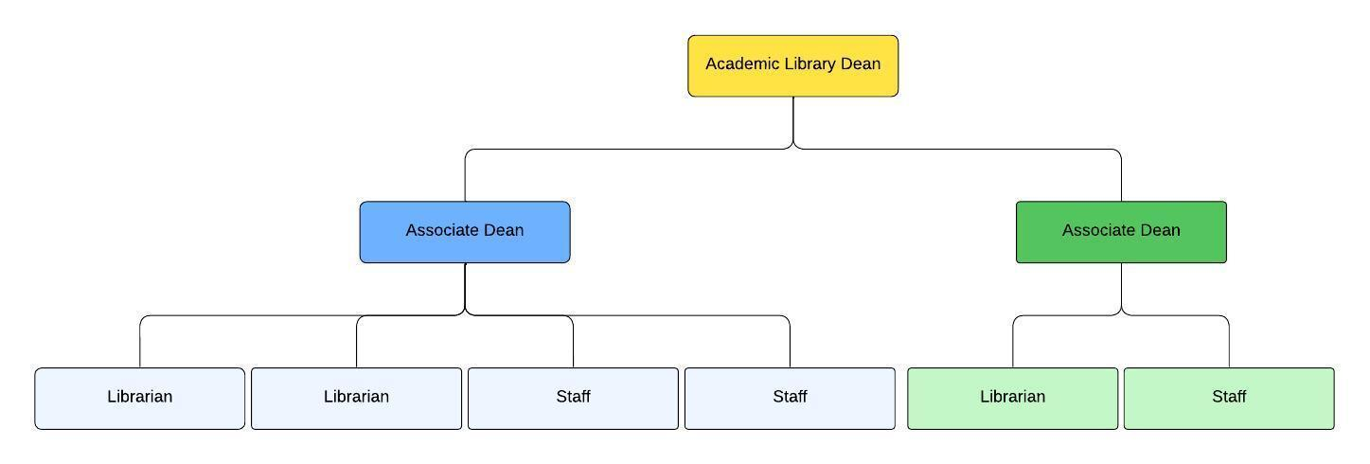
Note: Image created by author.

Block Quotations [delete before submitting]
Use block quotations for direct quotes that are made up of 40 words or more. Block quotations don’t use quotation marks, but rather they start on a new line and the whole block of text is indented by 0.5 in. If the quotation contains additional paragraphs, indent the first line of each extra paragraph an additional 0.5 in. For more information about formatting and citing block quotations, view the APA 7 manual or visit APA Style: Quotations. The example below showcases APA 7 block quote formatting [delete before submitting]

Clement (2020) expresses similar sentiments on the utility of filler text for article templates:
Suspendisse dapibus lorem pellentesque magna. Integer nulla. Donec blandit feugiat ligula. Donec hendrerit, felis et imperdiet euismod, purus ipsum pretium metus, in lacinia nulla nisl eget sapien. Donec ut est in lectus consequat consequat. Etiam eget dui. Aliquam erat volutpat. Sed at lorem in nunc porta tristique.

Acknowledgements (heading level 3, flush left, bold, italic, 12 pt font, Times New Roman)
Acknowledgements and Conflict of Interest Statement should begin on a new page, no matter where the article ends. Text after Acknowledgements and Conflict of Interest Statement begins as a new paragraph, each paragraph indented, and 1.15 spacing without extra spaces after paragraphs. This is sample body text. This is more sample body text. This is yet even more sample body text. And more. This is sample body text. This is more sample body text. This is yet even more sample body text. And more. This is yet even more sample body text. And more.

Conflicts of Interest Statement (heading level 3, flush left, bold, italic, 12 pt font, Times New Roman)
Acknowledgements and Conflict of Interest Statement should begin on a new page, no matter where the article ends. Text after Acknowledgements and Conflict of Interest Statement begins as a new paragraph, each paragraph indented, and 1.15 spacing without extra spaces after paragraphs. This is sample body text. This is more sample body text. This is yet even more sample body text. And more. This is sample body text. This is more sample body text. This is yet even more sample body text. And more. This is sample body text. This is more sample body text. This is yet even more sample body text. And more.

References (level 1 header, bold, 16 pt font, Times New Roman)
Test, M. (2013). All references should use APA 7 citation style. The Journal of Sample References, 6(2), 133-158. https://doi.org/testdoi1234

Test, T. (2020). All references should use APA 7 citation style. The Journal of Sample References, 10(52), 110-121. https://doi.org/testdoi1234
[References should be in alphabetical order, 1.15 spacing, one space in between entries. Your editors and copyeditors very much appreciate attention to APA style in the references. Delete this text before submitting.]

Appendix (heading level 1 flush left, bold, 16 pt font, Times New Roman)

Appendix A. Appendix Title (heading level 2, flush left, bold, 14 pt font, Times New Roman)
Appendices should begin on a new page, no matter where the article ends. Text after the appendix header begins as a new paragraph, each paragraph indented, and 1.15 spacing without extra spaces after paragraphs. This is sample body text. This is more sample body text. This is yet even more sample body text. And more. This is sample body text. This is more sample body text. This is yet even more sample body text. And more. This is yet even more sample body text. And more.

Appendix B. Appendix Title (heading level 2, flush left, bold, 14 pt font, Times New Roman)
Appendices should begin on a new page, no matter where the article ends. Text after the appendix header begins as a new paragraph, each paragraph indented, and 1.15 spacing without extra spaces after paragraphs. This is sample body text. This is more sample body text. This is yet even more sample body text. And more. This is sample body text. This is more sample body text. This is yet even more sample body text. And more. This is yet even more sample body text. And more.

[Appendices should have 1.15 spacing, appear after the references on a new page, and be labeled Appendix A., Appendix B., etc. and should be referenced appropriately in the text of the article. Delete this text before submitting.]

