Established
Anthony Bartolo & Angela Uriyo, Ph.D.,
West Virginia University

Keywords: Machine Embroidery, Tailored Details, Ageing
Statement of Purpose: The look, Established, was designed and to address a specific consumer’s clothing need, mainly pertaining to those who have additional clothing needs as they grow older. Designed for Spring/Summer 2023, this dress drew inspiration from a dress in the Christian Dior Spring/Summer runway show in 1996, as well as various other historical couture clothing with modest and classic looks. The goal was to create a dress for any occasion that is minimalistic, yet still unique and able to stand out in a crowd. The Established dress was created to show that anyone, regardless of age, can and should be able to still feel comfortable in their clothes and have their personal needs met at the same time.

Aesthetic Properties and Visual Impact: The words elegant, modest, timeless, and detailed best describe the Established dress. These words are best exemplified throughout the dress through elegant machine embroidery as a surface design, soft gathering at the shoulders, a modest hemline, a timeless and classic color palette, and extraordinary detail within the garment's construction. The garment is more fitted in places that were not identified as problem areas that come with older age and feature a looser or relaxed fit in areas that may be of issue to my older consumer. The garment’s elegant cut and pattern features are complimented with delicate machine embroidery throughout as well. This design is suitable for many occasions and can be worn to business meetings or social events.

Process, Technique, and Execution: The design and development process of the Established dress included design ideation and creation through Adobe Illustrator, material selection, drafting original patterns manipulated from torso and basic sleeve slopers, prototype development, model fitting on dress forms through pattern alterations, and final design construction. Inspiration throughout the design process was pulled from Christian Dior’s 1996 Spring/Summer runway show, current trends, and suitable Spring/Summer color palettes, fabrics, and styles. The drafted patterns were meant to have a slim fit in certain areas and looser fit in others, an idea that had be changed several times in order to achieve this desired look.
This knee length sheath dress features a shirt collar that opens to a button placket at the center front. My client had alluded to changes in her hand dexterity, and so I included large buttons and a side invisible zipper to facilitate her donning and doffing the garment. The buttons are also oversized to draw attention to the wearer’s face – a feature of her body she likes. The dress has a shaped empire waist on the front and back of it to elongate the wearers legs as well as create an illusion of an hourglass shape for my mesomorph-shaped client. Two double welt pockets with buttoned flaps were inserted along the top edge of the front waistband to add a functional yet tailored detail to this garment (see Figure 1). Bell sleeves created balance and visual interest to an otherwise semi-fitted silhouette. For fabrications I paired a black polyester fabric with a silk/crepe fabric to ensure comfortability for my client. To create the surface texture on the silk/crepe fabric, I created the design on Adobe Illustrator and printed a template which I transferred to the fabric with a marking tool and tracing paper, before machine embroidering it. This was done to enhance the surface texture and visual interest of the crème-colored silk/crepe fabric (see Figure 2).

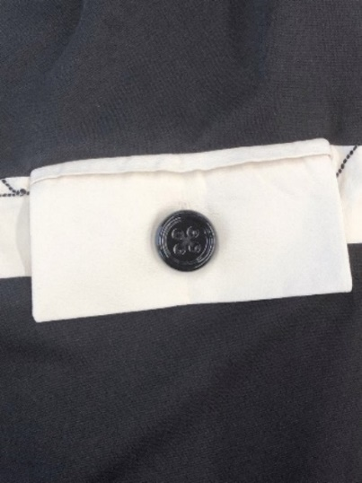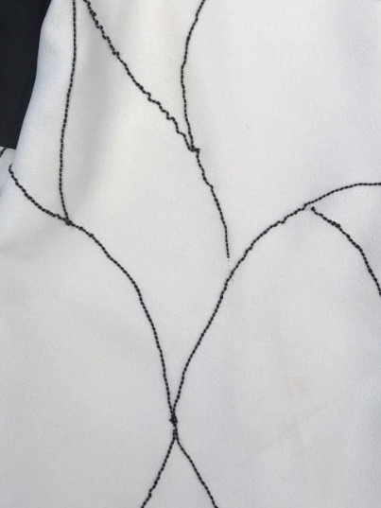
Figure 1. Double welt pocket with Figure 2. Machine embroidery on
buttoned flap crème-colored silk/crepe fabric

Cohesion: The cohesiveness of this look is portrayed using comfortable and soft fabrics, an ivory tone accent paired with a solid black dominant color tone, shoulder gathers, and the visualization of modesty and elegance. Worn on its own, the Established dress compliments the wearer’s desired features. Additionally, the color scheme of the two fabrics complements each other and help to liven up the look. The embroidery is simple and has a soft movement to it yet is still unique and distinctive. The Established dress is cohesive on its own and can easily be paired with various accessories.

Originality and Innovation: Inspired by historical couture with modest elements, the Established dress includes intricate detail through embroidery, gathers, and construction. This dress depicts my goal of the garment to seek modesty, elegance, and timelessness, all while meeting the needs of its consumer while embracing any self-conscious aspects of themselves they may have. This design balances simplicity with intricate detail. This look follows the aesthetics of Christian Dior using tailoring details, all while creating a unique and timeless garment. This dress embodies what it means to be proud and confident in your body while wearing your
clothing.
References
Administration for Community Living. (2021, May). 2020 Profile of Older Americans. https://acl.gov/sites/default/files/Aging%20and%20Disability%20in%20America/2020Pr ofileOlderAmericans.Final_.pdf
Christian Dior (n.d.). Retrieved from https://www.dior.com/en_us

