Consumer’s local retailer support during and after the pandemic: Empathy-altruism hypothesis perspective
Hyunjoo Im & Hyunok An, University of Minnesota
Introduction
Small, independent, local retailers have been severely impacted by the COVID-19 pandemic both because of the government regulations and because of consumer’s increased online purchases. Large national chains attracted more customers because they could provide better inventory, easier online shopping and delivery. However, this unprecedented crisis also sharply increased consumer awareness of the importance of small businesses in the local and overall economy, which consequently increased their willingness to pay for local products (Ryan, 2020). Consumers reportedly went out of their way to support small, local businesses and anticipate continued local support after the pandemic (Nextdoor, 2020). However, no study has systematically investigated the phenomenon. To understand what motivated consumers to support local retailers and whether their experiences predict future intentions, there is a need to investigate consumer motivations and intentions on the topic. Thus, the current study theoretically developed and tested a model to understand consumer local business support during the COVID-19 pandemic and future intention using the prosocial behaviors perspective.
Literature review
According to the empathy–altruism hypothesis (Batson, 1987), people are engaged in prosocial behaviors for two main psychological motivations, altruistic and egoistic motivations although altruistic motivation is the primary driver of prosocial behaviors (Toi & Batson, 1982). People are motivated to help others partly because of empathic concerns, the sympathetic other-oriented emotions (i.e., altruistic motivation), and partly because of their own feeling of distress caused by seeing others in need (i.e., egoistic motivation) (Cialdini et al, 1973; Batson, 1987). These two motivations trigger one’s internal values of prosocial behaviors, moral reasoning (Paciello et al., 2013), which then increases one’s desire to help others and helping behaviors.
The literature also documented how much vulnerable a target seems to people affects their motivations to help. Perceived vulnerability of a target evokes feelings of sympathy and develops an intention to care about the target (Dijker, 2014; Lishner et al., 2011). Because local businesses during the pandemic were under extreme stress, it is likely that they were viewed as very vulnerable, which in turn elicits the motivations for helping behaviors. It is also likely that the heightened awareness of the need of local businesses during the pandemic is positively associated with consumer intention to support them in the future.
The pandemic threatened not only the local businesses but also consumers (e.g., health concerns, job security threat). When people experience reduced control over their environment due to external threat, they tend to show ethnocentric attitude with high sensitivity to the source of threats and the tendency to help in-group (Fritsche et al., 2017) because they seek to restore their self-control through extended self in group membership (Reicher et al, 2010; Tajfel & Turner, 1979). Thus, it is plausible that consumer ethnocentrism is heightened due to the pandemic and ethnocentrism increases consumer sensitivity to vulnerability of local businesses, empathic concerns, personal distress, and local support. Taken together, the following research model and hypotheses were developed (see figure 1).
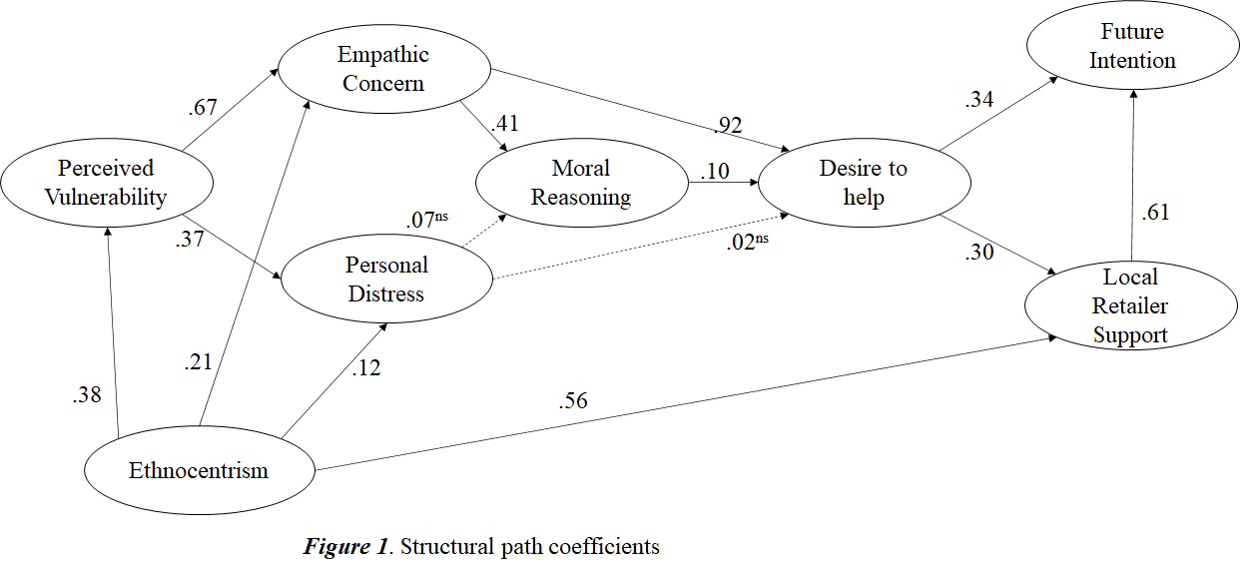
Methods
US adult consumers (n=301) were recruited from Amazon mTurk and completed an online questionnaire which included measurement items for perceived vulnerability of local retailers, empathic concerns, personal distress, desire to help local retailers, local support behaviors during the pandemic, and their future intention to support local businesses. Previously validated instruments were adapted for the current study context whenever possible.
Results & Discussion
The proposed model fitted the data well (Χ²=1534.862, df=763, p=.000, Χ²/df=2.012, CFI=.935, PCFI=.870, RMSEA=.058[.054;.062]). The results (see figure 1) generally supported our hypothesis that consumers supported local businesses for altruistic motivation during the COVID-19 pandemic because of their increased perception of vulnerability of local businesses. The degree of personal distress had no impact on consumer’s desire to help or actual support behaviors. Consistent with our reasoning, ethnocentrism influenced all aspects of the model from the perception of local businesses to motivations (i.e., empathic concerns, distress), to local support behaviors. Importantly, participant’s future intention to support local was positively associated with their local support behaviors during the pandemic, providing some evidence that increased current local support mindset is likely to continue after the pandemic.
Our findings emphasize the importance of two key elements in motivating consumer’s local support: vulnerability perception and in-group perception. Thus, it is important that local businesses actively engage in the local community to become an essential member of the community (i.e., an in-group member). Theoretically, the current study is in line with the studies which reported the critical importance of altruistic motivation in predicting prosocial behaviors (Toi & Batson, 1982; FeldmanHall et al., 2015). While the current study captured the pandemic-induced local support behaviors and consumer’s subjective belief for future support, further research is necessary to understand how long the effect (e.g., vulnerability perception, ethnocentrism) will sustain.
References
Batson, C. D., Fultz, J., & Schoenrade, P. A. (1987). Distress and empathy: Two qualitatively distinct vicarious emotions with different motivational consequences. Journal of personality, 55(1), 19-39.
Cialdini, R. B., Darby, B. L., & Vincent, J. E. (1973). Transgression and altruism: A case for hedonism. Journal of Experimental Social Psychology, 57, 626–631.
Dijker, A. J. (2014). A theory of vulnerability-based morality. Emotion Review, 6(2), 175-183
FeldmanHall, O., Dalgleish, T., Evans, D., & Mobbs, D. (2015). Empathic concern drives costly altruism. Neuroimage, 105, 347-356.
Fritsche, I., Moya, M., Bukowski, M., Jugert, P., de Lemus, S., Decker, O., ... & Navarro‐Carrillo, G. (2017). The great recession and group‐based control: Converting personal helplessness into social class in‐group trust and collective action. Journal of Social Issues, 73(1), 117-137.
Lishner, D. A., Batson, C. D., & Huss, E. (2011). Tenderness and sympathy: Distinct empathic emotions elicited by different forms of need. Personality and Social Psychology Bulletin, 37(5), 614-625.
Nextdoor. (2020). How COVID-19 has changed the way we shop locally. Retrieved from https://business.nextdoor.com/local/resources/how-covid-19-has-changed-the-way-we-shop-locally.
Paciello, M., Fida, R., Cerniglia, L., Tramontano, C., & Cole, E. (2013). High cost helping scenario: The role of empathy, prosocial reasoning and moral disengagement on helping behavior. Personality and Individual Differences, 55(1), 3-7.
Reicher, S. D., Spears, R., & Haslam, S. A. (2010). The social identity approach in social psychology. In M. S. Wetherell & C. T. Mohanty (Eds.), Sage identities handbook (pp. 45–62). London: Sage.
Tajfel, H., & Turner, J. C. (1979). An integrative theory of intergroup conflict. In W. G. Austin & S. Worchel (Eds.), The social psychology of intergroup relations (pp. 33–47). Monterey, CA: Brooks/Cole.
Ryan, T. (2020). Has COVID-19 made the ‘shop local’ message more real for consumers? Retailwire.com. Retrieved from https://www.retailwire.com/discussion/has-covid-19-made-the-shop-local-message-more-real-for-consumers/.
Tajfel, H., & Turner, J. C. (1979). An integrative theory of intergroup conflict. In W. G. Austin & S. Worchel (Eds.), The social psychology of intergroup relations (pp. 33–47). Monterey, CA: Brooks/Cole.
Toi, M., & Batson, C. D. (1982). More evidence that empathy is a source of altruistic motivation. Journal of personality and social psychology, 43(2), 281.

