Can AI match human experts? Consumer evaluation of AI- vs. human- curated products
Hyunjoo Im & Garim Lee, University of Minnesota
Introduction While the advancement of Artificial Intelligence (AI) technology enabled the algorithms to effectively simulate human intelligence, people still believe some uniquely human characteristics exist and machines would not perform as well (Longoni et al., 2019). One of the AI-driven business models is subscription box services, the business that curates and delivers a box of goods to consumers periodically (Baxter, 2015). While these subscription box services are becoming popular among consumers, little is known about how consumers respond to the curations made by the AI algorithm. To explore how consumers perceive and respond to these services, this study aims to compare consumers’ perceptions of recommendations from AI with those from humans in the context of fashion and meal subscriptions.
Literature review The role of source credibility on persuasion has been long demonstrated, and the perception of expertise and attractiveness determines source credibility (Harmon & Coney, 1982). When consumers receive curated boxes from the subscription services, who curated their boxes can influence their perception of source credibility, and thus their evaluation of the boxes they receive. Because selecting and combining the right items or ingredients require expertise in the area, creativity, and intimate knowledge of the customers (Baird, 2017), at least some aspects of the curation process require characteristics considered to be uniquely human (e.g., creativity, intuition, ability to consider individual consumer’s unique needs). Thus, compared with AI, consumers are likely to accept recommendations made by humans (H1). The superior effects of human recommender will be explained by (H2a) competence and (H2b) warmth, the two fundamental dimensions of social judgment (Fiske et al., 2007; Judd et al., 2005). Warmth captures the perceptions of an entity’s friendliness, trustworthiness, and sociability, while competence captures the perceptions of capability, skillfulness, and intelligence (Li et al., 2019). Consumers are known to be influenced by fuzzy, warm feelings as much as facts and competence of the source (Dubois et al., 2016). While (H3a) the uniquely human characteristics such as creativity and uniqueness consideration will enhance perception of competence of the recommender (i.e., mediation through competence), (H3b) perceived warmth is likely to directly enhance consumer intention as an affect-based heuristic cue (e.g., Schwarz & Clore, 2003). Furthermore, the mediating role of competence will be moderated by the product category type and consumer shopping goals (i.e., hedonic, utilitarian) because the goal of the consumers and the specific nature of the product category demand different degrees of uniquely human capabilities (H4a). However, the mediating role of warmth will not differ because perceived warmth creates a general positive feeling unrelated to specific product categories or shopping goals (H4b).
Methods The hypotheses were tested through a 2(product: fashion vs. meal) × 2(recommender: human vs. AI) between-subjects online experiment. Participants (n=216, Amazon Mturk, M_{age}=39.82 (11.14), Male 45.8%) were randomly assigned to one of the four conditions, signed up for a hypothetical subscription service, and completed the questionnaire that includes measures for perceived competence, warmth, creativity, uniqueness consideration, intention to accept the recommendation, and shopping goals. All measures were adapted from previous research, when possible. All multi-item scales showed high reliability (α>.83).
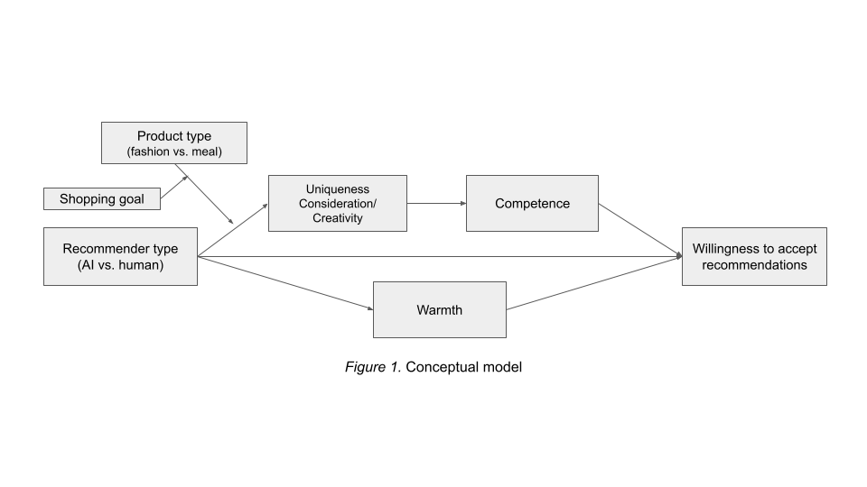
Results Consistent with H1, the participants in the human (vs. AI) recommender condition were more willing to accept the recommendations (M_{human}=4.23, M_{AI}=3.93, F=4.23, p=.041, partial η²=.02). As expected, competence (indirect effect=.32 [.14, .50]) and warmth (indirect effect=.53 [.32, .75]) mediated the effect. Thus, H2a and H2b were supported. The relationship between recommender type and willingness to accept recommendations was serially mediated by perceived creativity and competence (effect=.41 [.26, .60]) and uniqueness consideration and competence (effect=.11 [.02, .25]), supporting H3a. The indirect effect of recommender type on willingness to accept recommendations was not significant through uniqueness consideration and warmth but significant through perceived creativity and warmth (effect=.18 [.06, .31]). Thus, H3b was partially supported. H4 was tested using PROCESS macro (model 11) with 3 independent variables (the recommender type and product type as categorical variables, and shopping goal as a continuous variable) and 2 mediators (competence, warmth). The combined effect of product type and shopping goal significantly affected the indirect effect of recommender type on willingness to accept recommendations through competence (index=.41 [.04, .76]). Product type significantly moderated the mediating effect of competence for those with more utilitarian goals (index=-.66 [-1.24, -.04]), but not for those with more hedonic goals. The indirect effect of recommender type on willingness to accept recommendations through warmth was significant across the product types and shopping goals. Thus, H4 was supported.
Discussion This study extends the knowledge of subscription services by exploring consumers’ responses to the recommender type (AI vs. human). As expected, the participants were more likely to accept the recommendations from human because they perceived higher competence and warmth from human recommender than AI. Furthermore, creativity perception was a critical factor because it explained the role of both competence and warmth. While we hypothesized that creativity is a factor to increase competence, our result suggests that perceived creativity also contributes to the feeling of warmth. Why our participants associated creativity with warmth is unclear and further research is necessary to validate and understand this finding.
The results supported that warmth perception prevails for both fashion and meal recommendations and for both shopping goals, suggesting that consumers still seek human touch in these recommendations, and subscription services must consider emphasizing and incorporating human experts in the curation process. Our findings showed that whereas hedonically-oriented participants equally considered competence as an important reason for accepting recommendations across product categories, participants with utilitarian goals were significantly different in considering competence of AI and human recommender. An examination of mean values revealed that fashion consumers with utilitarian goals particularly showed reservation for AI recommendations due to concerns for AI’s ability to match human ability. Further research is necessary to understand the underlying reason for the findings.
References
Baird, N. (2017). Why don’t more retailers ‘get’ curation? Retailwire.com. Retrieved from https://retailwire.com/discussion/why-dont-more-retailers-get-curation/.
Baxter, R. K. (2015). The Membership Economy: Find Your Super Users, Master the Forever Transaction, and Build Recurring Revenue. McGraw-Hill.
Dubois, D., Rucker, D. D., & Galinsky, A. D. (2016). Dynamics of communicator and audience power: The persuasiveness of competence versus warmth. Journal of Consumer Research, 43, 68-85.
Fiske, S. T., Cuddy, A. J., & Glick, P. (2007). Universal dimensions of social cognition: Warmth and competence. Trends in Cognitive Sciences, 11(2), 77-83.
Harmon, R. R., & Coney, K. A. (1982). The persuasive effects of source credibility in buy and lease situations. Journal of Marketing Research, 19(2), 255-260.
Judd, C. M., James-Hawkins, L., Yzerbyt, V., & Kashima, Y. (2005). Fundamental dimensions of social judgment: understanding the relations between judgments of competence and warmth. Journal of Personality and Social Psychology, 89(6), 899.
Li, X., Chan, K. W., & Kim, S. (2019). Service with emoticons: How customers interpret employee use of emoticons in online service encounters. Journal of Consumer Research, 45(5), 973-987.
Longoni, C., Bonezzi, A., & Morewedge, C. K. (2019). Resistance to medical artificial intelligence. Journal of Consumer Research, 46, 629-650.
Schwarz, N., & Clore, G. L. (2003). Mood as information: 20 years later. Psychological Inquiry, 14, 294–301.

