Differences in foot measurement between female and male firefighters

Jeyeon Jo¹, Ziyun Zhang,¹ Linsey Griffin², Susan Sokolowski³, Meredith McQuerry⁴, and Huiju Park¹
¹Cornell University, ²University of Minnesota, ³University of Oregon, ⁴Florida State University

Keywords: firefighter, foot, 3D scanning

Introduction Fire boots are mostly optimized for male firefighters, who represent the majority of the firefighting population (Chetkovich, 1997; Park et al., 2015). However, the percentage of female firefighters has increased from 3.7% in 2000, reaching 8% in 2018, and the number goes up to 11% in the case of volunteer firefighters in United States (Evarts & Stein, 2020; Hulett et al., 2008a). Female firefighters experience more challenges than male firefighters due to ill-fitting equipment (Park & Hahn, 2014) and 47% of them reported fit issues with fire boots (Hulett et al., 2008b). A majority of female firefighters wear male fire boots due to a lack of support from both the market and fire departments, which causes improper fit of the boots with negative impacts on their walking and safety on unfavorable fireground (Boorady et al., 2013). Krauss et al. (2010) investigated differences between female feet and last design and concluded that the down-graded men’s lasts for women’s shoe design is inappropriate due to significant differences in foot shape between females and males. Previous studies found that on average, females had smaller arch height and width than males at the same foot length (Chaiwanichsiri et al., 2008; Krauss et al., 2008). Nevertheless, there is no study on how fire boots should be designed based on analysis of the variation between female and male firefighters’ feet, nor on the differences between firefighters’ and civilians’ feet.
Research Purpose and Method This study compared the foot morphology of male and female firefighters through 3D scanning, and analyzed foot measurements from Size USA, a large anthropometric dataset of the general US population, in order to interpret sex differences in foot morphology to improve the design of fire boots for improved comfort and mobility for female firefighters. The dominant foot of 74 female and 22 male firefighters was scanned using a hand-held 3D scanner. Geomagic® (3D Systems, NC) was used to take six measurements from each scanned foot: foot length, foot width, medial/lateral ankle height, diagonal ankle circumference and arch height. This study also analyzed the foot measurement data of the general U.S. population using SizeUSA data to support the finding from the firefighters, which includes foot length, foot width, medial/lateral ankle height, and foot girth. When the sizes of both feet were available, the size of the right foot was chosen. Since the ranges of foot length of females and males are different, there was a need to set a range of interest where the range of the female foot length and that of the male foot length overlapped. As shown in Table 1, the data collected from firefighters indicates that foot length between 9.5 – 10.75” is the area occupied by both sexes. It corresponds with the distribution of foot length in the SizeUSA data, only the given range of which includes more than 100 participants of both sexes. Therefore, most of the analysis of this study focused on the range of interest. Statistical analysis was performed by using R.
Table 1. Number of participants in this study and SizeUSA by foot length.
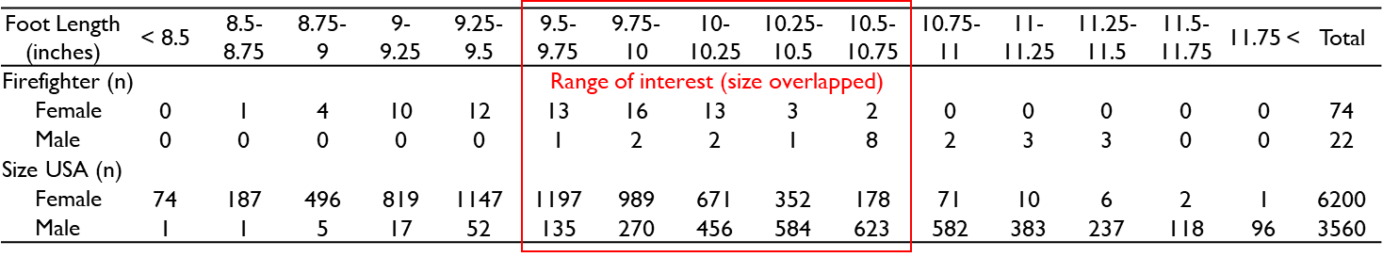
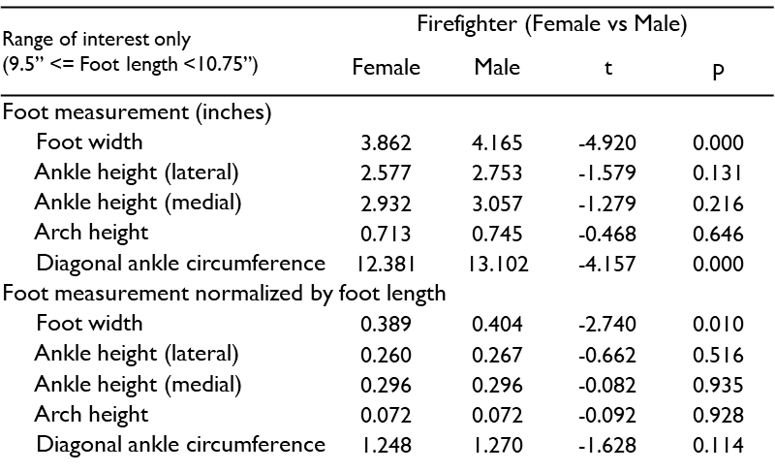
Result and Discussion Because the fit issues with fire boots for female firefighters come mostly from wearing boots designed for the feet of males and since foot length is one of the primary factors in choosing a shoe size, the focus of the analysis was to find a difference in size by sex within the same foot length range slot. However, due to a lack of male firefighter participants, conducting a statistical test within each foot length slot did not produce reliable data. To break through this, each foot measurement was normalized with regard to foot length by dividing it by the foot length of the participant, which generated a proportional foot dimension. T-test on the normalized figures within the range of interest indicates that there is a significant difference in foot width proportion to foot length between female and male firefighters (Table 2). It implies that the foot of female firefighters is slimmer than that of males, even when their foot length is same. This result may be related to the nature of female firefighters’ issues, as reported by a previous study (Boorady et al., 2013), with ill-fitting fire boots causing clunky walking, rapid fatigue development, and their boots to fall off behind them as they walk. The SizeUSA data with a lot more participants not only supported this finding but also raised a possibility of potential differences in other measurements, if there are more firefighter participants. Comparison of foot measurements by sex in the general population clearly shows that there is a significant difference between females and males in all foot measurements (foot width, lateral/medial ankle height and foot girth) and their proportions to foot length, even when they are in the same foot length slot (p <.001). Within the range of interest of this study, the mean difference of the four measurements varies from 0.572 to 0.063 inches, which can create major fitting issues, potentially followed by accidents on the fire ground. Last, comparison between firefighters and the general U.S. population also indicated that foot width (p_{female}<.001, p_{male}<.001) and medial ankle height (p_{female}<.05, p_{male}<.05) are significantly different between the two sexes. The mis-match cause ill-fitting of fire boots, limiting the lower body mobility. It should be noted that their negative impact will be even larger in female firefighters; in a previous study, the range of motion at the ball of the foot and ankle had a greater reduction in female firefighters wearing fire boots, which implies a greater risk compared to their male counterparts (Park et al., 2015). The consistent findings revealing the distinct characteristics of female firefighter foot dimensions emphasize the need for fire boots specifically designed for the population using female boot models, as dual sizing can’t offer ideal fit for female firefighters.
Table 2. Comparison of foot measurements between female and male firefighters
References
Boorady, L. M., Barker, J., Lin, S.-H., Lee, Y.-A., Cho, E., & Ashdown, S. P. (2013). Exploration of Firefighter Bunker Gear Part 2: Assessing the Needs of the Female Firefighter. 8(2), 12.
Chaiwanichsiri, D., Tantisiriwat, N., & Janchai, S. (2008). Proper shoe sizes for Thai elderly. The Foot, 18(4), 186–191. https://doi.org/10.1016/j.foot.2008.05.001
Chetkovich, C. (1997). Real Heat: Gender and Race in the Urban Fire Service. Rutgers University Press.
Evarts, B., & Stein, G. P. (2020, February). NFPA report—U.S. fire department profile. https://www.nfpa.org/News-and-Research/Data-research-and-tools/Emergency-Responders/US-fire-department-profile
Hulett, D. M., Bendick, M., Thomas, S. Y., & Moccio, F. (2008a). Enhancing Women’s Inclusion in Firefighting in the USA. The International Journal of Diversity in Organizations, Communities, and Nations: Annual Review, 8(2), 189–208. https://doi.org/10.18848/1447-9532/CGP/v08i02/39562
Hulett, D. M., Bendick, M., Thomas, S. Y., & Moccio, F. (2008b). A National Report Card on Women in Firefighting (p. 20). International Association of Women in Fire & Emergency Services.
Krauss, I., Grau, S., Mauch, M., Maiwald, C., & Horstmann, T. (2008). Sex-related differences in foot shape. Ergonomics, 51(11), 1693–1709. https://doi.org/10.1080/00140130802376026
Krauss, I., Valiant, G., Horstmann, T., & Grau, S. (2010). Comparison of Female Foot Morphology and Last Design in Athletic Footwear—Are Men’s Lasts Appropriate for Women? Research in Sports Medicine, 18(2), 140–156. https://doi.org/10.1080/15438621003627216
Park, H., & Hahn, K. H. Y. (2014). Perception of firefighters’ turnout ensemble and level of satisfaction by body movement. International Journal of Fashion Design, Technology and Education, 7(2), 85–95. https://doi.org/10.1080/17543266.2014.889763
Park, H., Trejo, H., Miles, M., Bauer, A., Kim, S., & Stull, J. (2015). Impact of firefighter gear on lower body range of motion. International Journal of Clothing Science and Technology, 27(2), 315–334. https://doi.org/10.1108/IJCST-01-2014-0011

