Holistic Sensory Evaluation Method for Assessment of Novel Materials and Apparel Products
Armine Ghalachyan, Washington State University and
Elena Karpova, The University of North Carolina at Greensboro
Keywords: Holistic sensory evaluation, novel materials, apparel, touch, smell, hearing, sight
Background. Novel fibers and materials, solar cells, 3D-printed components, and other unconventional materials are increasingly being incorporated in apparel products to meet the growing demand for innovative products such as smart textiles, wearable technology, and sustainable products (Lehmann et al., 2018). These materials often have specific characteristics such as odors, sounds, and textures that may evoke new and unusual sensations affecting consumer satisfaction and product acceptance. Capturing and evaluating the full range of sensory characteristics of novel materials and products as well as holistically assessing consumer perceptions becomes essential for adoption of such innovative products. However, no methods for holistic sensory evaluation of novel materials and apparel exist.
Sensory evaluation evokes, measures, analyzes and interprets reactions to product characteristics perceived through the five human senses: sight, smell, taste, touch, and hearing (ASTM E253-15a, 2015; Stone et al., 2012). Sensory evaluation of textiles and apparel has traditionally focused on two senses: sight (appearance characteristics) and touch, with tactile and thermal comfort receiving most attention. In fact, the term sensory has often been used interchangeably with tactile sensation in scholarly publications. Yet, apparel is experienced through the senses of hearing and smell as well (Davis, 1996). For example, garments may embody odors due to encapsulated essential oils or make sounds during movement. This paper presents a newly developed holistic sensory evaluation method for textiles and apparel based on the senses of sight, touch, hearing, and smell—all the human senses, with the exception of taste. The method was carefully documented, described, and successfully tested with 34 participants to evaluate sensory characteristics and consumer perceptions and acceptance of a novel sustainable material, bacterial cellulose.
Method and instrument. A three-part instrument was developed for the new holistic sensory evaluation method. This was partially based on Free-Choice Profiling (FCP), a descriptive sensory evaluation method used in food sciences used for identifying product characteristics and qualities as perceived and described by product evaluators or assessors (Moskovitz et al., 2008).
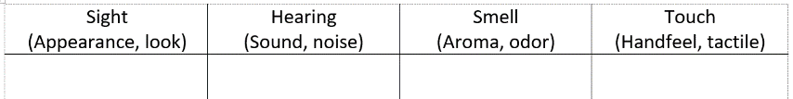
In Part 1 of the instrument, participants are asked to examine material swatches provided and generate attributes describing the sensory characteristics of the material. Four columns, labeled sight, hearing, smell, and touch, are provided to help participants generate and record as many attributes as possible for each sense (Figure 1).
Figure 1. Part 1 – Generating attributes describing material
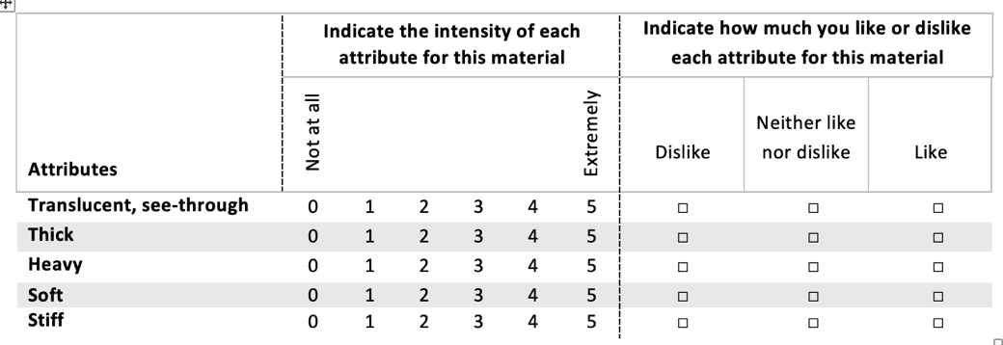
In Part 2, participants are asked to evaluate the material by rating the intensities of 25 pre-determined material attributes on a scale of 0 (not at all) to 5 (extremely). Participants are also asked to indicate how much they like or dislike each attribute on a scale of 1 (dislike) to 3 (like) (Figure 2). The list of the 25 attributes describing the material was developed in advance by a panel of experts including textiles and apparel scholars. During the panel meeting, the experts examined the material swatches, then individually generated attributes characterizing the material based on each of the four senses. In total, 93 attributes were generated with an average of 15.5 per expert. Next, all attributes were written on a board for further discussion, evaluation, elimination of redundancies, and consolidation of the attributes, carried out by the same experts. As a result, the number was reduced to 25 attributes, which were used to develop the Part 2 of the instrument as described above (Figure 2).
Figure 2. Excerpt from Part 2 – Rating intensities and liking of material attributes
It is recommended to develop a list of attributes specific to a novel material or product being evaluated, if a suitable list cannot be found. For bacterial cellulose material specifically used to test the method, eight attributes were generated describing the appearance characteristics (uneven color, dull, non-uniform, leather-like, plastic-like, wrinkly, spotted, translucent; eight – the texture (thick, heavy, sticky, soft, textured, stiff, vinyl-like, dry); seven – the smell (vinegary, spicy, sweet, overripe-fruit, ammonia, pleasant); and three – the sound (squeaky, paper-like-sounding, vinyl-like-sounding).
Part 3 of the instrument was designed to measure overall liking and perceived acceptability of the material for apparel and accessories. Participants are asked to indicate: (a) how much they like or dislike the material (from 1=dislike extremely to 5=like extremely); (b) how acceptable the material is for clothing; and (c) how acceptable the material is for fashion accessories (from 1=not at all acceptable to 5=very acceptable). A final open-ended question encourages participants to provide additional comments about the characteristics and use of the material.
Conclusions and implications. This paper is the first to present a method for a holistic sensory evaluation method for assessment of novel textiles and apparel. The three-part method was useful in gaining a broad understanding about bacterial cellulose, the novel sustainable material used to test the method. Attributes generated in Part 1 were particularly valuable in gaining fundamental information about the material, as perceived and described by potential consumers, and identifying areas for improvements for further material development. Part 2 of the evaluation was essential for determining the magnitudes of the product attributes experienced (e.g., extremely rough) and whether particular attributes were perceived as positive (liked textured and disliked translucent qualities). Part 3 was useful for assessing the overall liking of the material and its perceived suitability for apparel and accessories from consumer perspective.
Researchers can apply the holistic sensory evaluation method to assess new materials and apparel products, including wearable technology, smart clothing, sustainable materials, as well as regular apparel products. The method allows in-depth understanding of various characteristics of materials and products based on the four senses of sight, smell, touch, and sound. This comprehensive assessment of consumer perceptions of products helps identify areas for improvement, avoid new product failure, and provide language for marketing these products using consumer descriptors. Businesses may find the method useful in evaluating new products and materials during product development stages.

References

ASTM E 253-15a. (2015). Standard terminology relating to sensory evaluation of materials and
products. In Annual Book of ASTM Standards. West Conshohocken, PA: ASTM International.
Davis, M. L. (1996). Visual design in dress (3rd Ed.). Upper Saddle River, New Jersey: Prentice
Hall.
Lehmann, M., Tärneberg, S., Tochtermann, T., Chalmer, C., Eder-Hansen, J., Seara, J. F., …
Deichmann, S. (2018). Pulse of the fashion industry 2018. Global Fashion Agenda and The Boston Consulting Group. Retrieved in June 2018 from chrome-extension://oemmndcbldboiebfnladdacbdfmadadm/http://www.globalfashionagenda.com/download/3700
Moskovitz, H. R., Munoz, A., M., & Gacula, M. C. (2008). Viewpoints and controversies in
sensory science and consumer product testing. Wiley-Blackwell.
Stone, H., Bleibaum, R. N., & Thomas, H. A. (2013). Sensory evaluation practices (4th ed.).
Amsterdam: Elsevier.

