How do consumers’ attitudinal ambivalence of trust and distrust toward social media influencers interplay and influence their choice decisions?
¹Tsz Ching CHOW*, ²Bingwen CHEN*, ³Chunsheng LI⁺, Ph.D., ⁴Chung-Wha (Chloe) KI*, Ph.D.
*Hong Kong Polytechnic University; ⁺Macau University of Science and Technology
Phenomenon statement: Consumers increasingly consider social media influencers (SMIs) as a valuable source of information. SMIs are social media users who have built a sizable network of followers by sharing their daily lives and creating online contents that inspire followers and who have qcauired the potential to exert influence over their audience (Ki & Kim, 2019). People are following SMIs primarily because they trust what SMIs say online. Given that a message conveyed by SMI is considered more trustworthy than a similar message conveyed by a celebrity or a brand itself, an increasing number of fashion brands are collaborating with SMIs and asking them to create branded content that includes product mentions or endorsements—a practice referred to as influencer marketing. But ironically, the more commercialized the SMI landscape becomes, the more consumers are losing trust in SMIs and developing a distrust toward SMIs’ branded contents.
Problem statement: The SMI literature was developed largely by focusing on two lines of research: one line of research focused on identifying the reasons why people build trust with SMIs and how this trust affect their consumption behavior (Lou & Yuan, 2019). The second line has put more attention to identifying the factors affecting consumers’ distrust toward SMIs (Feng et al., 2020). Despite the knowledge gained by previous studies, many of them overlooked the fact that people can have mixed feelings of both trust and distrust toward SMIs and their online contents. Since it is fairly common for consumers to experience dual attitudes and that these mixed attitudes influence their behavior simultaneously (Mano & Oliver, 1993), it is important to understand: 1) whether consumers experience attitudinal ambivalence of trust and distrust in response to SMIs and their shared contents; 2) what principal factors trigger consumers’ trust, distrust, or ambivalence; and 3) If the emotions of trust and distrust are mixed, how they interplay and influence consumers’ behavior. Building on attitudinal ambivalence theory (Gardner, 1987), we used a mixed method approach to address these issues
Theoretical framework: Ambivalence refers to a state of mind in which an individual has mixed beliefs/feelings towards an object. Much evidence exists of individuals’ ambivalence experiences across diverse consumption contexts. Among which, the most prevalent is consumers’ trust and distrust (Kim & Ahmad, 2013). For a long time, trust and distrust have been conceptualized as extreme values that are situated at the opposite ends of the same conceptual spectrum that cannot coexist. However, the recent stance is that people can simultaneously hold both trust and distrust toward an attitude-related subject (Chang & Fang, 2013), meaning that the presence of trust does not necessarily mean the absence of distrust. In the SMI context, will consumers trust and/or distrust SMIs?
Study 1: Study 1 conducted a focus group to identify two issues: 1) the factors affecting consumers’ liking and following of SMIs and 2) the factors affecting consumers’ trust, distrust, and/or ambivalence towards SMIs. We invited 10 informants to the focus group, which was held on July 15, 2019. The focus group was conducted face to face for more than an hour. The informants were asked to share their thoughts about the following discussion questions: “Why do you like and follow your choice of SMIs?” and “Do you trust SMIs? If so, or if not, then why?” The interview was audio-recorded and then transcribed into a written form for thematic content analysis using an inductive coding approach. Regarding the question “Why do you like and follow your choice of SMIs?”, our inductive analysis results identified two main themes: 1) SMIs’ personality traits and 2) the contents SMIs create. More specifically, our inductive coding analysis identified four sub-themes under each category. Regarding SMIs’ personality traits, two sub-themes emerged as the factors affecting the informants’ liking and following: 1) similarity and 2) attractiveness with induction rates of 100% and 70%, respectively. Regarding SMIs’ content-related traits, we identified two sub-themes: 1) visual aesthetics and 2) informativeness with an induction rate of 100% for both. Example excerpts include:
Informant 1: “I follow Tina Wong because I can’t agree more with her. I find myself nodding when I read her posts about sustainable fashion. We share a lot in common, and that is why I like her and trust her.” [SMI’s trait – similarity]
Informant 5: “Pamela Cheung looks so pretty and high-class, even when she is wearing Zara. So I trust and follow her fashion styling tips.” [SMI’s trait – attractiveness]
Informant 3: “I follow Agnes’ IG because I like copying her Instagram grid layouts. This is a really a good template to follow.” [SMI’s content-driven trait – visual aesthetics]
Informant 7: “She is one of the famous beauty influencers. I started to follow her because she shares a lot of skin-care tips for acne-prone skin like me. ...” [SMI’s content-driven trait – informativeness]
Notably, informants 1, 5, and 7 implied that they not only liked SMIs, but grounded on their liking, also developed trust towards the contents that SMIs shared online. In the second half of the focus group interview, we focused more on discussing whether SMIs triggered the informants’ trust, distrust and their ambivalence of both. If so, then why. Our inductive analysis findings showed that informants develop trust (100%), distrust (90%), and ambivalence (90%). When consumers reported trust, their trust was toward SMIs. In contrast, ambivalence was expressed towards SMIs’ branded contents as they perceived SMIs’ branded contents to be excessive and intrusive (i.e., perceived ad clutter).
Informant 6: “Even though the contents of Ling Cheng’s posts say #sponsored or #ad, I trust them. …If influencers don’t have trust in the products they promote, they won’t take the risk of sponsoring them...”
Informant 8: “When many influencers post contents that introduce the same, newly launched product at the same timing, it is obvious that the brand paid them. I don’t trust those contents.”
Informant 4: “For me, trust is 60% and distrust is 40%, which is still fair enough to follow Sue Chang’s product recommendations.”
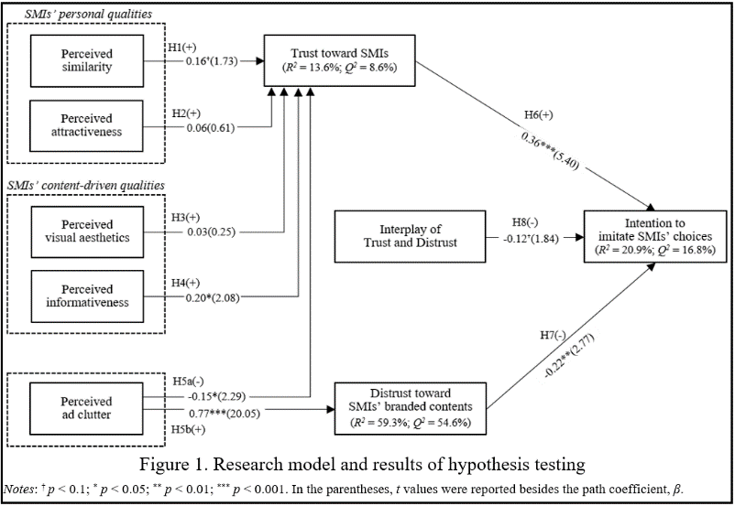
Study 2: Based on Study 1’s findings, in Study 2, we developed and empirically tested a model of the antecedents and consequences of consumers’ ambivalence in the SMI context. H1&2: The more consumers find SMIs as similar to themselves (H1) and attractive (H2), the more they develop trust towards the SMIs. H3&4: The more consumers find SMIs’ contents to be visually aesthetic (H3) and informative (H4), the more they develop trust towards the SMIs. H5: Perceived ad clutter in SMIs’ branded contents yields attitudinal ambivalence, alleviating consumer trust toward SMIs [H5a (-)] and aggravating distrust toward SMIs’ branded contents [H5b (+)]. H6: Consumers’ trust toward SMIs affect their intention to imitate the SMIs’ product/brand choices (i.e., imitation intention) positively. H7: Consumers’ distrust toward SMIs’ branded contents affect imitation intention negatively. H8: Consumer trust and distrust have a significant interaction effect on imitation intention, in such a way that higher distrust will weaken the positive association between trust and imitation intention.
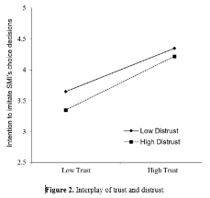
We developed an online survey through which 200 responses were collected and analyzed with PLS-SEM. According to our results, all Hs were supported except for H2 and H3 (Figures 1 and 2).
Implications: Our research offers new insights for researchers and practitioners in several aspects. First, our findings show that consumers experience not only trust or distrust, but an ambivalence of both in response to SMIs’ branded contents. Our trust-related findings show that both SMIs’ personal traits (similarity) and content driven traits (informativeness) contribute to establishing trust with consumers. In contrast, the more consumers found a SMI’s contents contained advertisements that are excessive and irritating (perceived ad clutter), the more they felt skeptical of the SMIs’ branded contents. While it is easily predicted that consumers’ trust and distrust affect imitation intentions positively and negatively, respectively, we found that the interaction effect of trust and distrust on imitation intention is significant and negative, in that an increased distrust weakened the positive association between trust and imitation intention. Stated another way, the negative effect of distrust on imitation intention was insignificant when consumers expressed high trust. These findings would be valuable to practitioners who are making special efforts in (re)gaining consumer trust through SMIs.
References
Chang, Y. S., & Fang, S. R. (2013). Antecedents and distinctions between online trust and distrust: Predicting high-and low-risk internet behaviors. Journal of Electronic Commerce Research, 14(2), 149.

Feng, Y., Chen, H., & Kong, Q. (2020). An expert with whom I can identify: The role of narratives in influencer marketing. International Journal of Advertising, 1-22. https://doi.org/10.1080/02650487.2020.1824751

Gardner, P. (1987). Measuring ambivalence to science. Journal of Research in Science Teaching, 24(3), 241-247.

Ki, C. W., Cuevas, L. M., Chong, S. M., & Lim, H. (2020). Influencer marketing: Social media influencers as human brands attaching to followers and yielding positive marketing results by fulfilling needs. Journal of Retailing and Consumer Services, 55, 1-11, Article 102133. https://doi.org/10.1016/j.jretconser.2020.102133

Ki, C. W., & Kim, Y. K. (2019). The mechanism by which social media influencers persuade consumers: The role of consumers’ desire to mimic. Psychology & Marketing, 36(10), 905-922. https://doi.org/10.1002/mar.21244

Kim, Y. A., & Ahmad, M. A. (2013). Trust, distrust and lack of confidence of users in online social media-sharing communities. Knowledge-Based Systems, 37, 438-450.

Lou, C., & Yuan, S. (2019). Influencer marketing: How message value and credibility affect consumer trust of branded content on social media. Journal of Interactive Advertising, 19(1), 58-73.

Mano, H., & Oliver, R. L. (1993). Assessing the dimensionality and structure of the consumption experience: Evaluation, feeling, and satisfaction. Journal of Consumer Research, 20(3), 451-466.

Keywords: Social media influencers; mixed emotions; ambivalence; trust and distrust

