Who are the Business Influencers?
The Underlying Relationship between Employees and Strategic Retail Change
Danielle Testa, Linda Niehm, and Jessica Hurst, Iowa State University

Keywords: Commitment, transformational change, employees, influence, retail

Introduction. Academicians and professionals alike have posited that employees can influence business ventures and business actions early in their career (Oh, Weitz, & Lim, 2016). However, the direct relationship between non-managerial employees and business performance needs to be further explored within retail in order to understand the relationship and impact (Chuang & Liao, 2010). As retail businesses undergo large strategic changes, an opportunity exists to evaluate the potential impact of non-managerial employees on business performance.
Strategic change is unavoidable for many retailers; something that was recognized before the COVID-19 pandemic (Amed et al., 2018). The State of Fashion 2019 reported, “Now used to uncertainty after living with it for so many years, in 2018 fashion executives have begun to think less about survival and much more actively about their strategic agenda” (Amed et al., 2018). The purpose of this paper is to introduce a conceptual framework that connects the influence of employees to business performance while retailers undergo strategic change. The framework explores the impact of employees’ commitment, knowledge, and managerial relationships as they impact business performance.
Theoretical Basis. This study assumes a dualistic perspective in which a social structure is embedded within the grand system. The overarching perspective presented is systems theory (Littlejohn & Foss, 2011), in which the employees, managers, and business operations exist within the retail organization undergoing strategic change. The relationships embedded within this system are framed by social exchange theory (Littlejohn & Foss, 2009). Social exchange theory refers to the exchange of both tangible and intangible assets. Researchers utilizing social exchange theory have demonstrated that organizations and managers showing commitment to employees have been repaid, supporting the proposed relationship between the employees and business performance (Knippenberg, 2020).
Figure 1. Conceptual framework of employees’ impact on business performance.
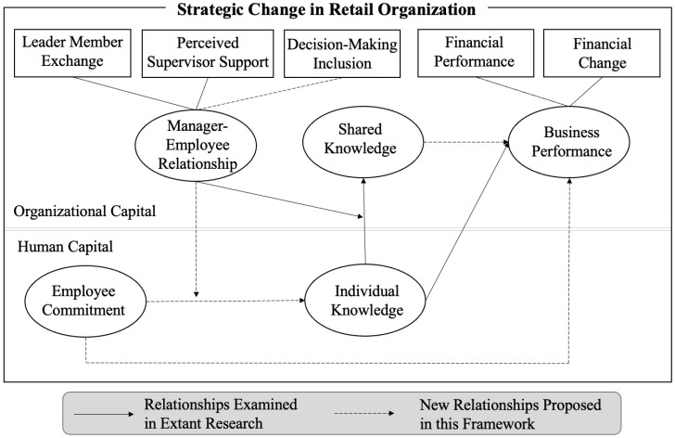

Conceptual Framework. This framework was inspired by extant research in strategic decision-making and knowledge management (Arnold et al., 2019; Razzaq et al., 2019). A holistic framework connecting employeelevel variables to overarching business performance while undergoing strategic change has not been tested. The framework illustrates the proposed relationship between employees’ intangible psychologies and tangible business performance (Figure 1).
There are two sections of the framework; the lower portion represents human capital which is retained within individual employees. Human capital refers to attributes and traits of individual employees that create economic value for an organization (Lin & Tang, 2016). The upper portion of the framework represents organizational capital. Organizational capital relates to the organizational philosophy, systems, and cross-functional processes (Black & Lynch, 2005). The framework illustrates the transition of an employee’s knowledge or idea into an organization to transition from human capital to organizational capital and the overarching impact of intellectual capital on business performance.
The human capital variables include employee commitment and individual knowledge. The independent variable is employee commitment. As a vital asset to organizations, employees may contribute more or less to organizations based on their level of commitment. The relationship between employee commitment and business performance is mediated by individual knowledge. Individual knowledge includes tacit knowledge which cannot easily be written down or verbalized and is often developed throughout an individual’s industry career (Leonard & Sensiper, 1998). It also includes knowledge gained through personal experiences which may inform professional opinions and decisions (Reber, 1989). Personal experiences may be of importance for non-managerial employees who utilize their experiences as both retail professionals and consumers to inform their business recommendations.
The organizational capital variables include shared knowledge, the manager-employee relationship (MER), and business performance. Through teamwork, an individual’s knowledge may be shared throughout the organization and become organizational capital (Lin & Tang, 2016). Sharing knowledge throughout an organization allows application to multiple processes. An employee’s impact on business performance is further diffused by the MER. The MER moderates the relationship between employee commitment and knowledge (individual and shared) within the proposed framework. The MER moderates the desire and growth of individual knowledge, as well as the sharing of knowledge throughout the organization. The MER addresses leader-member exchange, the quality of communication and exchange between supervisors and employees (Selvarajan, Singh, & Solansky, 2018). It also addresses perceived supervisor support, the presence (or lack of) support that may impact an employee’s contributions to the organization (Kottke & Sharafinski, 1988). Further, MER addresses decision-making inclusion, a new variable addressing employees’ role in strategic processes.
The outcome variable in this conceptual framework is business performance. Business performance is measured through financial performance and financial change. Researchers have emphasized financial metrics for measuring outcomes such as profit, net sales, and return on assets (Childs & Jin, 2015). Financial change is a further metric to provide insights on financial performance verses a previous period in time in order to interpret relativity. Combining these metrics provides optimal insights into employees’ variables impact.
Future Research and Application. As many retailers have accelerated strategic changes within their organizations during the past several years (Amed et al., 2018), this framework has been developed to encourage exploration of the non-managerial human resources that may influence business performance during strategic changes. By exploring the role of nonmanagerial employees, the unique and impactful role of individuals during early periods of their career may be better understood. Academicians may utilize this framework to create linkages between knowledge management, human resource, and business research. Industry professionals may use the framework for a measurable context of human capital within their organizations. Further, as the professional environment changes, understanding constructs such as commitment and shared knowledge, and how they impact business performance, may allow businesses to prepare for the workforce of the future.

References

Amed, I., Berg, A., Balchandani, A., Beltrami, M., Andersson, J., Hendrich, S., & Rölkens, F.
(2018). The state of fashion 2019. The Business of Fashion and McKinsey & Company, 1– 107. Retrieved from https://www.mckinsey.com/industries/retail/our-insights/the-state-offashion-2019-a-year-of-awakening
Arnold, T.J., Grewal, D., Motyka, S., Kim, N., Sharma, A., & Srivastava, R. (2019). Store manager–store performance relationship. Journal of Retailing, 95(2), 144–155. https://doi.org/10.1016/j.jretai.2019.03.002
Black, S.E., & Lynch, L.M. (2005). Measuring organizational capital in the new economy. In Measuring Capital in the New Economy (pp. 205–234).
https://doi.org/10.7208/chicago/9780226116174.003.0007
Childs, M.L., & Jin, B. (2015). Firm factors that influence internationalisation and subsequent financial performance of fashion retailers. Journal of Service Theory and Practice, 25(1),
95-114. https://doi.org/10.1108/JSTP-09-2013-0204
Chuang, C.H., & Liao, H.U.I. (2010). Strategic human resource management in service context: Taking care of business by taking care of employees and customers. Personnel Psychology, 63(1), 153-196.
Knippenberg, D.V. (2020). Social identity-based leadership and the employee– organization relationship. In L.M. Shore, J.A.M. Coyle-Shapiro, & L.E. Tetrick (Eds.), The EmployeeOrganization Relationship: Applications for the 21st Century (pp. 85–112). New York: Routledge.
Kottke, J.L., & Sharafinski, C.E. (1988). Measuring perceived supervisory and organizational support. Educational and Psychological Measurement, 48, 1075–1079.
Leonard, D. & Sensiper, S. (1998). The role of tacit knowledge in group innovation. California Management Review, 40(3), 112–132.
Lin, X., & Tang, H. (2016). A framework for human resource configurations in knowledgeintensive organizations. International Journal of Business Administration, 7(1). https://doi.org/10.5430/ijba.v7n1p1
Littlejohn, S.W. & Foss, K.A. (2009). Encyclopedia of communication theory. Thousand Oaks, CA: Sage Publications.
Littlejohn, S.W., & Foss, K.A. (2011). Theories of human communication. Long Grove, IL: Waveland Press, Inc.
Oh, H., Weitz, B., & Lim, J. (2016). Retail career attractiveness to college students: Connecting individual characteristics to the trade-off of job attributes. Journal of Retailing and
Consumer Services, 31, 345–354. https://doi.org/10.1016/j.jretconser.2016.04.012
Razzaq, S., Shujahat, M., Hussain, S., Nawaz, F., Wang, M., Ali, M., & Tehseen, S. (2019).
Knowledge management, organizational commitment and knowledge-worker performance:
The neglected role of knowledge management in the public sector. Business Process
Management Journal, 25(5), 923–947. https://doi.org/10.1108/BPMJ-03-2018-0079
Reber, A. S. (1989). Implicit learning and tacit knowledge. Journal of Experimental Psychology: General, 118(3), 219–235. https://doi.org/10.1037/0096-3445.118.3.219
Selvarajan, T.T., Singh, B., & Solansky, S. (2018). Performance appraisal fairness, leader member exchange and motivation to improve performance: A study of US and Mexican employees. Journal of Business Research, 85, 142–154.

