Coping with Covid-19: How resilient consumers adjust clothing consumption amid the pandemic
Chuanlan Liu, Sibei Xia, and Chunmin Lang, Louisiana State University

Research Rationale. The COVID-19 pandemic has disrupted the consumers’ consumption equilibrium and habits. Recent studies have found that consumers radically shift their demand for certain essential product categories and significantly reduce their spending on nonessentials and discretionary purchases (Arora et al., 2020; Knowles, Ettenson, Lynch, & Dollens, 2020). Fashion clothing buying remains a largely discretionary purchase, making it more susceptible to economic shocks caused by the pandemic. Furthermore, all consumption is anchored to time and location (Sheth, 2020), especially for fashion clothing consumption. Occasions that require different style of dress, which allow consumers to show their different selves no longer exist during the lockdown. Stores that allow consumers to search, try on, and purchase fashion clothing were shut down. Consumers experience serious disruption in fashion clothing consumption and the fashion industry was hit by the global pandemic the hardest.
However, the pandemic crisis might also create opportunities for fashion brands and businesses since it has produced rapid, sustained shifts in environments, markets, and consumers’ needs and wants (Knowles et al., 2020). Consumption is habitual (Sheth, 2020). Once a routine in consumption preferences is established, it becomes habitual and is difficult to change. In normal times, gaining consumers’ attention and changing their preferences is a pricey endeavor. However, when consumers go through daily life disruptions, they will have to readjust their behavior patterns to reach a rebalanced consumption equilibrium (Liu & Black, 2011; Thoits, 1995). Therefore, consumers are more likely to change their consumption needs, wants, attitudes, and behavior, which leads them to be more actively open to new lifestyles and changes in consumption patterns, and more susceptible to intervention by marketers (Andreasen, 1984; Moschis, 2007).
According to Moschis (2007), consumer changes in consumption patterns or preferences in responding to life events, lift status change, disasters, or the global pandemic can be considered as the fundamental mechanism of stress coping. According to Bandura (1977), coping self-efficacy regulates human functioning to buffer stress and depression, as well as promote resilience to life adversity. One of the major ways in which coping self-efficacy makes use of its effects on socioemotional functioning processes is through facilitating individuals to muster and carry on their coping efforts to transform undesired environments into what they prefer (Benight & Bandura, 2004). Consequently, resilient consumers with high coping self-efficacy tend to engage in active consumption adjustment to reach a rebalanced equilibrium, or new normal (Liu & Black, 2011). Also, resilient individuals with high coping-self-efficacy are more likely to actively cope with life disruptions and end up with positive coping outcomes that last a longer time (Lazarus & Folkman, 1987) .
To this end, this research intends to fulfill two research objectives: (1) to find out how consumers have changed their clothing consumption patterns or habits amid covid-19, and (2) to examine how resilient consumers change their clothing consumption to identify what value means to them as they establish lasting new clothing consumption routines while going through the disruption caused by the global pandemic. Our findings provide practical directions for fashion clothing marketers to navigate the crisis and locate growth through better meeting of consumers changing needs, wants, and lifestyles.
Research Design. We applied a two-phase multi-method approach to fulfill our research objectives. The first phase employed an exploratory qualitative study through mining collected text data from Twitter to identify consumers’ changes in clothing consumptions. We searched and collected tweets related to fashion clothing consumption changes from January 1, 2020, through September 31, 2020, to cover various pandemic stages (pre-pandemic, lockdown, reopening, and post-reopening). A total of 68,511 tweets were collected. Through a systematic content mining process, we identified themes related to consumers’ responses, reactions, transitions, and adaption related to fashion clothing consumption through the global pandemic.
The second phase intends to fulfill the second research objective. An online survey was designed and administered in early December 2020. Measures include scales developed based on findings from the first phase of the study to assess consumers’ changes in clothing consumption, and the established scales to assess an individual’s coping self-efficacy (Benight & Harper, 2002). A national sample was recruited through the research company, Qualtrics.com. A total of 418 out of 1291 collected responses were considered valid and used for analyses.
Findings and Discussions. Semantic and sentiment analysis in the phase 1 study uncovered three dimensions of changes in fashion clothing consumption: value shift, comfort over style, and pent-up demand. In the phase 2 study, a total of 25 items measuring fashion consumption changes were subject to an Exploratory Factor Analysis (EFA). After removing items with low communalities, low factor loading, or high cross factor loading, the final round of EFA revealed a three-factor measurement model. This finding is consistent with the phase1qualitative inquiry results (see Table 1).
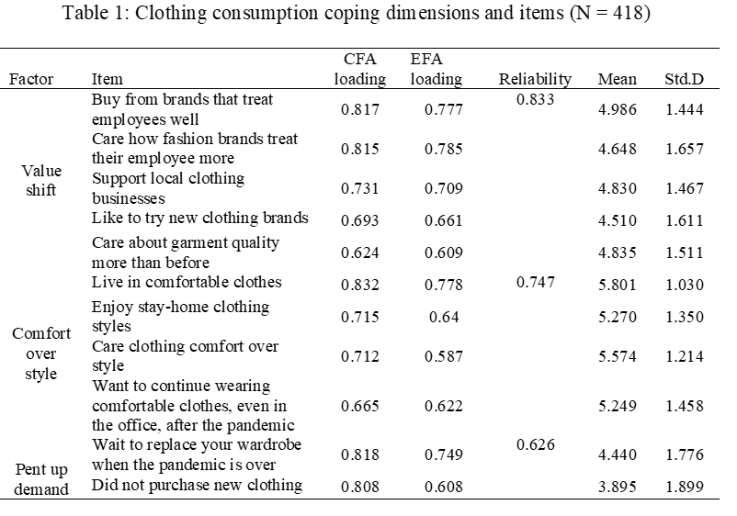
A cluster analysis was conducted with 7 items of coping self-efficacy as input variables. Two clusters emerged, with the resilient group having high coping self-efficacy (n₁ = 224) and the other group having low coping self-efficacy (n₂ = 194). A MONOVA analysis found that resilient individuals are more likely to have value shifts, and prefer comfort over style. There is no difference in terms of pent up demand for fashion clothing consumption among consumers with different levels of coping self-efficacy.
Our study offers insights based on the theory of emotions and coping to help explain and predict consumer
responses, reactions, and adaptions associated with fashion clothing consumption to inform future research and marketing practice. We found that consumers are more aware of business ethics. For instance, resilient consumers cope with the pandemic by buying from brands that treat employees well, caring about how fashion brands treat their employees more. These findings indicate that fashion marketers may have opportunities to develop a “kind economy”. Also, we found that disrupted consumption is also linked with pent-up demand. The longer time consumers are deprived of fashion clothing consumption, the stronger desires they will have for fashion clothing consumption. Another managerial implication is that the fashion business must learn to adapt business operations to meet consumers’ changing needs and wants for comfort. Overall, fashion businesses and brands need to be more resilient to meet consumers’ changing needs, wants, and desires.
References:
Andreasen, A. R. (1984). Life status changes and changes in consumer preferences and satisfaction. Journal of Consumer Research, 11(3), 784-794.
Arora, N., Charm, T., Grimmelt, A., Ortega, M., Robinson, K., Sexauer, C., & Yamakawa, N. (2020). A global view of how consumer behavior is changing amid COVID-19. Mcknsey and Company. April.
Bandura, A. (1977). Self-efficacy: toward a unifying theory of behavioral change. Psychological review, 84(2), 191.
Benight, C. C., & Bandura, A. (2004). Social cognitive theory of posttraumatic recovery: The role of perceived self-efficacy. Behaviour research and therapy, 42(10), 1129-1148.
Benight, C. C., & Harper, M. L. (2002). Coping self‐efficacy perceptions as a mediator between acute stress response and long‐term distress following natural disasters. Journal of Traumatic Stress: Official Publication of The International Society for Traumatic Stress Studies, 15(3), 177-186.
Knowles, J., Ettenson, R., Lynch, P., & Dollens, J. (2020). Growth opportunities for brands during the COVID-19 crisis. MIT Sloan Management Review, 61(4), 2-6.
Lazarus, R. S., & Folkman, S. (1987). Transactional theory and research on emotions and coping. European Journal of personality, 1(3), 141-169.
Liu, C., & Black, W. (2011). Post-disaster consumer coping: consumption adjustment. ACR Asia-Pacific Advances.
Moschis, G. P. (2007). Life course perspectives on consumer behavior. Journal of the Academy of Marketing Science, 35(2), 295-307.
Sheth, J. (2020). Impact of Covid-19 on consumer behavior: Will the old habits return or die? Journal of Business Research.
Thoits, P. A. (1995). Stress, coping, and social support processes: Where are we? What next? Journal of health and social behavior, 53-79.

