The Effects of Need for New Fashion Styles and Environmental Attitude on Consumer Investment and Commitment

Hye-Shin Kim (University of Delaware) and Eunjoo Cho (University of Arkansas-Fayetteville)

Conceptual Framework and Hypotheses. Consumers tend to seek new styles and designs to fulfill their experiential or hedonic shopping needs which is a consumer trait commonly associated with the fashion products (Kwon & Workman, 1996). The fashion industry, noted for its planned obsolescence by triggering needs for new fashion styles with new collections multiple times a year, has generated public debate of the need to support the 3Rs of fashion sustainability (recycle, reduce, and reuse). As such, consumers' need for new fashion styles is framed as a contradictory value to consumers' attitude toward environmental sustainability. However, prior studies found that fashion orientation and shopping behavior were positively related to eco-friendly clothing consumption. For example, Gam (2010) found that consumers with high interest in being well-dressed and shopping enjoyment show higher purchase intentions regarding eco-friendly clothing. This study develops a conceptual framework based on Gam (2010) and the investment model (Rusbult, 1983) that examines how consumer need for new fashion styles and environmental values influence their relationship with favorite brands.

According to Rusbult (1983), commitment to a relationship increases with increase in satisfaction, decline in alternatives, and increase in investment. This relationship model was adopted by Sung and Choi (2010) in which they discuss various forms of investment in a brand such as personal resources, time, and money, which can be viewed as a major indicator of commitment (Sung & Choi, 2010). In addition, a consumer’s investment in brands creates psychological ties that motivate the consumer to maintain the relationship with the brand (Smith & Barclay, 1997). First, this study tests the relationships among satisfaction, investment, and commitment for a list of favorite brands self-reported by consumers (H1, H2, & H3). Because the collected data already reflects a variety of favorite brand choices, availability of alternative choices was not included in the model.

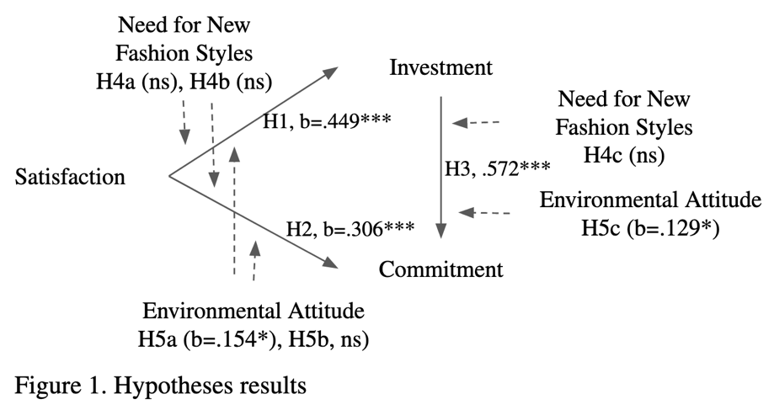
Next, we examined the moderating effects of (1) need for new fashion styles and (2) environmental attitude on the consumer investment and commitment model. We propose the relationships among the three variables in the investment model (H4a, H4b, & H4c) will be stronger for consumers with higher need for new fashion styles. Similarly, we propose that relationships among the three variables in the investment model (H5a, H5b, & H5c) will also be stronger for consumers with environmental values.

Data Collection. Data was collected using an online survey administered through Qualtrics. Through an online posting in the Amazon Mechanical Turk (MTurk) crowdsourcing platform, 242 female “workers” were recruited in return for a nominal payment. Prior literature confirms research samples from this online panel to be more demographically diverse and representative of the U.S. population compared to standard internet or convenience samples typically used in academic research (Buhrmester et al., 2011). The data collection instrument and methods were approved by the University’s Human Subjects Institutional Review Board (IRB). In the first section of the survey, participants were asked to list fashion brands that they most frequently purchased when shopping for fashion or related products. Participants were then asked to think of “the list of frequently purchased brands” they answered questions in the survey which included the level of satisfaction with frequently purchased brands (Picon et al., 2014), investment in frequently purchased brands (De Wulf, et al., 2001), and commitment to frequently purchased brands (De Wulf Odekerken-Schroder, & Iacobucci, 2001; Khan et al., 2020; Kim et al., 2008). Consumer attitude towards fast fashion was measured by a new scale developed by the researchers. In addition, consumer attitude towards environmental sustainability (Kim et al., 2016; Stern et al., 1999) were measured. All scaled items were scored on a 7-point Likert scale with endpoints “strongly disagree” and “strongly agree”.

Data Analysis and Results. Confirmatory factor analysis (CFA) validated the measures for the five constructs in the study: fit indices (PCMIN/DF=1.471; CFI=.978; GFI=.919; AGFI=.890; SRMR=.041; RMSEA=.044; PCLOSE=.765), factor loadings (.660 to .914), composite reliability (CR>0.7), convergent validity (AV>.5), and discriminant validity (MSV<AVE) were all acceptable. Cronbach’s alphas for constructs ranged from .819 to .930. AMOS was used to test the relationship among variables representing the conceptual framework (satisfaction, investment, and commitment) using structural equation modeling. Goodness of fit indices indicated a good fit (PCMIN/DF=1.977; CFI=.980; GFI=.948; AGFI=.911; SRMR=.041; RMSEA=.064; PCLOSE=.156). The three hypothesized paths in the model H1: Satisfaction-> Investment, H2: Satisfaction->Commitment, and H3: Investment->Commitment) were significant. In order to test the moderating effects of need for new fashion styles and attitude toward environmental sustainability, mean values for each variable were derived from the combination of items that represented each variable using SPSS. Next, standardized values were derived for each variable and product terms were computed for the interaction effects (e.g., satisfaction x need for new fashion styles). AMOS was used to test simple regression path models to examine the interaction effects on the dependent variables. Consumers’ environmental attitude strengthened the relationship between (1) satisfaction and investment and (2) investment and commitment. Consumers’ need for new fashion styles did not moderate the relationship among variables but instead showed a direct effect on investment in frequently purchased brands.

Discussion and Implications. As predicted, the relationship among the three variables (satisfaction, commitment, and investment) were significant for the self-reported listing of frequently purchased fashion brands. While the study shows that consumers' need for new styles did not influence the relationship of the variables, consumers with a higher level of environmentally sustainable attitude tend to form stronger relationships in terms of investment and commitment with their favored brands compared to consumers with higher needs for new fashion styles. The findings highlight a unique marketing opportunity for brands to build a stronger relationship with consumers with environmental values. On the other hand, data analysis showed consumers' need for new fashion styles influence a higher level of investment in brands offering a transactional opportunity for brands compared to a relationship building opportunity.

References

Buhrmester, M., Kwang, T., & Gosling, S. D. (2011). Amazon’s Mechanical Turk: A new source of inexpensive, yet high-quality, data? Perspectives on Psychological Science, 6(1), 3–5. https://doi.org/10.1177/1745691610393980
De Wulf, K., Odekerken-Schröder, G., & Iacobucci, D. (2001). Investments in consumer relationships: A cross-country and cross-industry exploration. Journal of Marketing, 65(4), 33–50. https://doi.org/10.1509/jmkg.65.4.33.18386
Gam, H. J. (2011). Are fashion-conscious consumers more likely to adopt eco-friendly clothing? Journal of Fashion Marketing and Management: An International Journal, 15, 178-193. https://doi.org/10.1108/13612021111132627
Khan, I., Hollebeek, L. D., Fatma, M., Islam, J. U., Riivits-Arkonsuo, I. (2020). Customer experience and commitment in retailing: Does customer age matter? Journal of Retailing and Consumer Services, 57,(Nov), 102219. https://doi.org/10.1016/j.jretconser.2020.102219
Kim, H., Kim, J., Oh, K. W., & Jung, H. J. (2016). Adoption of eco-friendly faux leather: Examining consumer attitude with the value-belief-norm framework. Clothing and Textiles Research Journal, 34(4), 239–256. https://doi.org/10.1177/0887302X16656439
Kim, J., W., Choi, J., Qualls, W., & Han, K. (2008). It takes a marketplace community to raise brand commitment: The role of online communities. Journal of Marketing Management, 24(3-4), 409-431. doi: 10.1362/026725708X306167
Kwon, Y. H., & Workman, J. E. (1996). Relationship of optimum stimulation level to fashion
Behavior, Clothing and Textiles Research Journal, 14(4), 249-256.
https://doi.org/10.1177/0887302X9601400404
McNeill, L., & Moore, R. (2015). Sustainable fashion consumption and the fast fashion conundrum: fashionable consumers and attitudes to sustainability in clothing choice. International Journal of Consumer Studies, 39(3), 212-222. https://doi.org/10.1111/ijcs.12169
Picón, A., Castro, I., & Roldán, J.,L. (2014). The relationship between satisfaction and loyalty: A mediator analysis. Journal of Business Research, 67(5), 746-751. https://doi.org/10.1016/j.jbusres.2013.11.038
Rusbult, C. E. (1983). A longitudinal test of the investment model: The development (and deterioration) of satisfaction and commitment in heterosexual involvements. Journal of personality and social psychology, 45(1), 101. https://doi.org/10.1037/0022-3514.45.1.101
Smith, J. B., & Barclay, D. W. (1997). The effects of organizational differences and trust on the effectiveness of selling partner relationships. Journal of marketing, 61(1), 3-21.
https://doi.org/10.1177/002224299706100102
Stern, P. C., Dietz, T., Abel, T., Guagnano, G. A., & Kalof, L. (1999). A value–belief–norm theory of support for social movements: The case of environmentalism. Human Ecology Review, 6, 81–97.
Sung, Y., & Choi, S. M. (2010). “I won't leave you although you disappoint me”: The
interplay between satisfaction, investment, and alternatives in determining consumer–
brand relationship commitment. Psychology and Marketing, 27(11), 1050-1073. https://doi.org/10.1002/mar.20373

