The Morbid Beauty of Fungi

Jung Eun Lee
Virginia Tech

Contextual Review and Concept While some people see fungi as disgusting and dangerous, organically related to decay and dirt, they are essential for human life and the health of the natural environment (Lange, 2014; Nai & Meyer, 2016). Fungi break down organic material, clean toxic substances, change waste into feed ingredients, and strengthen crops as the climate changes (Lange, 2014; Nai & Meyer, 2016). What is more, fungi are essential for food processing, being vital ingredients in bread, wine, beer, and cheese, and they are host organisms for manufacturing many drugs (Lange, 2014). Because fungi are a symbol of decay, deconstruction, and revival, they have inspired many artists (Nai & Meyer, 2016), including recent fashion designers such as Iris Van Herpen, whose 2021 Spring collection (Farra, 2021).
The purpose of the present design work is to create garments inspired by fungi using freestanding embroideries to reflect the beauty of fungi and their connectivity to all life on Earth. In this design project, I digitized images of fungi and explored freestanding computerized embroidery techniques. The challenge was to experiment with diverse stitching styles and settings to find those best suited for freestanding embroidery. This is a trial and error process because too few stitches make the embroidery fragile and high-density stitching makes it hard for needles to pass through the fabric, and some will break. The embroidery technique I use was inspired by Meredith Woolnough, an Australian artist whose method of freehand machine embroidery is not easily reproduced while my designs are—being manipulated and scaled, using a digitized computer embroidery process. Woolnough’s artwork is also limited to wall art, and designers at previous ITAA exhibitions applied their embroidery designs to small garment sections only, they are not, technically, freestanding embroideries (Moretz, 2013; Rorah, 2014; Sun, 2013). Thus, to my knowledge, no designer or artist has applied complex freestanding embroideries to create 3D structured embellishments on garments.
Aesthetic Properties and Visual Impact I created the freestanding embroideries by incorporating the aesthetics of fungi and the elegant surfaces via embroidered and knotted threads. Vibrant colored structures of fungi shapes were created using the adjunction colors of red, orange, and yellow. I used unbleached linen and cork fabric, made by shaving cork oak tree bark, to transfer the fungi’s life in nature and express its ecological connectivity. I placed fungi embroideries on the dress asymmetrically to create visual attractions and dynamics, while I developed the skirt hem as an asymmetric shape to keep the overall visual balance with asymmetric placements on the embroidered pieces. I included diverse textures, such as cork fabric and the surface of the embroidered thread, to add compelling design elements. I kept the structure of the dress simple, which draws the eye to the visual impact of freestanding 3D-shaped fungi embroideries.
Process, Technique, and Execution I began by experimenting with freestanding fungi embroideries. I searched for photographs of fungi to provide inspiration for and the shape of the embroidery designs. After tracing the shapes in Adobe Photoshop, I transferred them to Adobe Illustrator to vectorize and revise the shapes. I used Bernina Embroidery Software 8 to digitize the vector images and create the embroideries (see Fig 1). To embroider the digitized fungi shapes, I used a Bernina Embroidery B500. I experimented with various stitch types (e.g., step fill, satin fill, and lacework fill) and settings to find those best suited for freestanding fungi embroideries; I found that star step fill worked best for my designs. The final fungi designs were modified and scaled to create diverse shapes and sizes. The digitized fungi shapes were embroidered on a water-soluble stabilizer (see Fig 2), soaked in water, and dried to create free-standing embroideries. After creating the embroideries, I worked on the base dress. Pattern making by draping was used to create patterns for the dress. Linen fabric was cut and sewn to create the top part of the dress and cork fabric made the skirt. Then, the freestanding fungi embroideries were placed in a visually pleasing way and hand-sewn onto the dress.

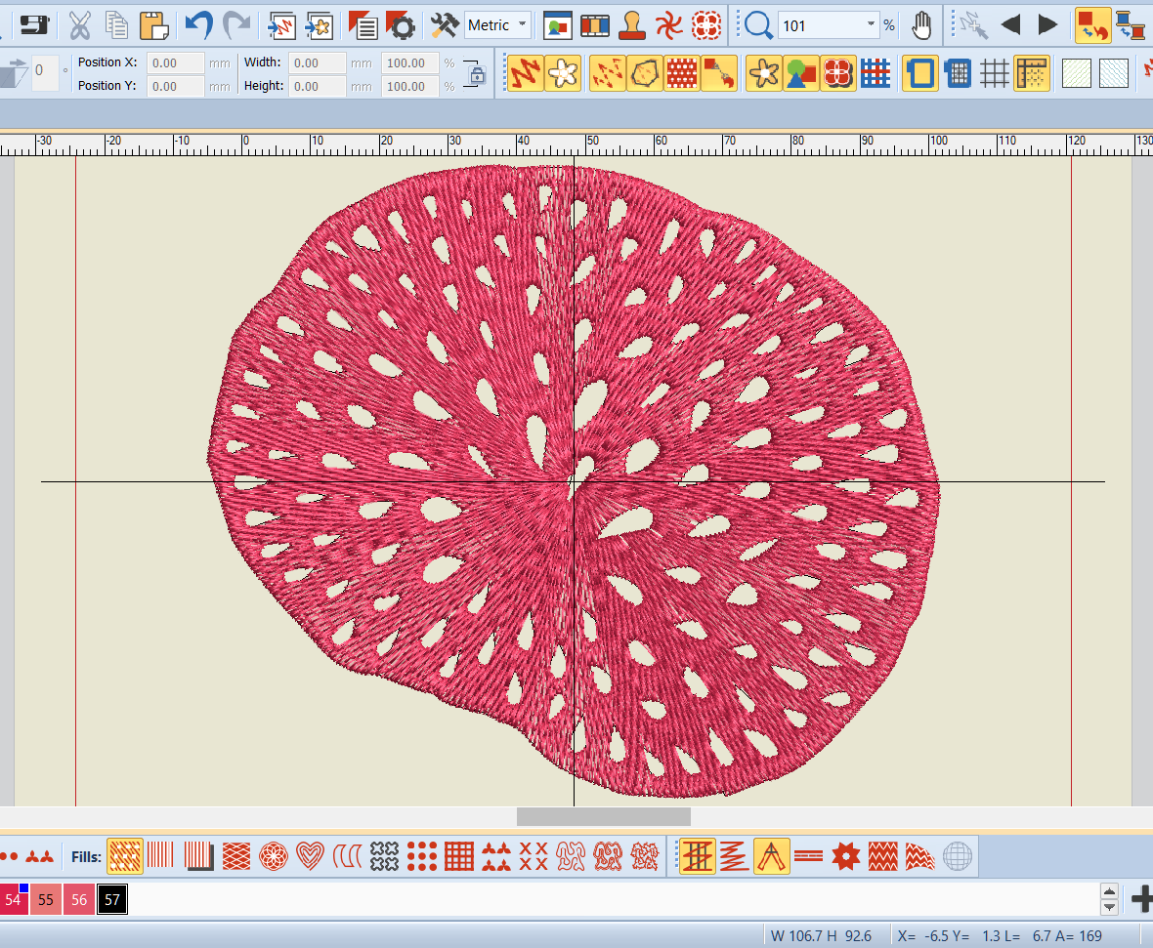 | 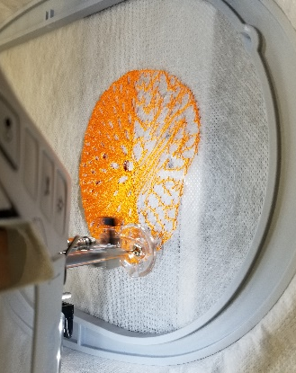
Fig 1. Digitized fungi embroidery using Bernina Embroidery Software | Fig 2. Embroidering a fungi design on a water-soluble stabilizer

Cohesion The finished dress provides cohesiveness in the overall garment design by expressing the beauty of fungi and conveying the freestanding embroidery. I emphasized the beauty of the fungi with bright colors and 3D shapes using freestanding embroidery techniques. By using a cork fabric, I was able to express the idea of nature and the connectivity of all life. Furthermore, the experimental trial and error process was valuable—the final freestanding fungi embroideries are detailed and enchanting, and strong enough to hold the 3D shape of the fungi.
Design Contribution and Innovation This design shows how complex embroideries can be digitized and created as freestanding embroideries, which can contribute to the field of embroidery design. Because other garment designers traditionally embroider using small areas sewn onto fabrics (Moretz, 2013; Rorah, 2014; Sun, 2013), the present method is a new way to create dramatic 3D freestanding embroideries on garments. Furthermore, although a previous artist has created complicated freestanding embroideries, her design was made by freehand embroideries. The present design project shows how complex freestanding embroidery can be digitized and reproduced successfully. The design is unique, integrating complex embroidered patterns with garments that are reproducible using a novel technique.

References
Farra, E. (2021). You aren’t tripping: Fungi are taking over fashion. https://www.vogue.com/article/fungi-mushrooms-fashion-inspiration-mycelium
Lange, L. (2014). The importance of fungi and mycology for addressing major global challenges. IMA Fungus, 5(2), 463-471.
Moretz, C. (2013). Belle curves. International Textile and Apparel Association (ITAA) Annual Conference Proceedings. https://www.iastatedigitalpress.com/itaa/article/2289/galley/2162/view/
Nai, C., & Meyer, V. (2016). The beauty and the morbid: Fungi as source of inspiration in contemporary art. Fungal Biology and Biotechnology, 3(1), 1-5.
Rorah, W. (2014). Engineered embroidery. International Textile and Apparel Association (ITAA) Annual Conference Proceedings. https://www.iastatedigitalpress.com/itaa/article/2932/galley/2805/view/
Sun, L. (2013). Naturally refined series: Rippled. International Textile and Apparel Association (ITAA) Annual Conference Proceedings. https://www.iastatedigitalpress.com/itaa/article/2266/galley/2139/view/

