Basketball Shoes: Women’s Preferences and Purchasing Behavior
Introduction: Despite the long-standing involvement of women in the sport, basketball shoe design defaults to men’s feet. In 2018, women’s basketball shoes made-up only 1 percent of all basketball shoe sales in America, a conundrum given that 25 percent of basketball players are female (Mirabella, 2018; Lynn et al., 2012). This suggests that the selection of women shoes is not meeting the female players’ needs. The goal of this study was to better understand women’s basketball shoe preferences and purchasing behavior. The guiding research questions for this study were: What factors influence the purchasing behaviors of female basketball players in Canada when choosing their basketball shoes? How does this compare to the selection of basketball shoes sold and targeted toward women? Current empirical research has focused on the functional needs of male basketball players to determine attributes needed to reduce injury and improve performance using quantitative methodologies (Brauner,
Zwinzscher & Sterzing, 2012; Daack and Senchina,2014; Jiang, 2020; Liu, Wu & Lam, 2017;
Mohr, Trudeau, Nigg, B. & Nigg, S. 2016; Luczak, Burch, Smith,
Lamberth & Carruth, 2020; Luczak, Burch, Smith, Lamberth, Carruth, Crane, Hoppa &Burgos 2020). Other researchers have examined the expressive and aesthetic consumer purchasing influences (Mehra, 2017; Belén del Río,
Vázquez & Iglesias, 2001; Silva, Madhushani & Jayalath, 2020; Deng,
Hui & Hutchinson, 2010) and designing sportswear for women (Feather,
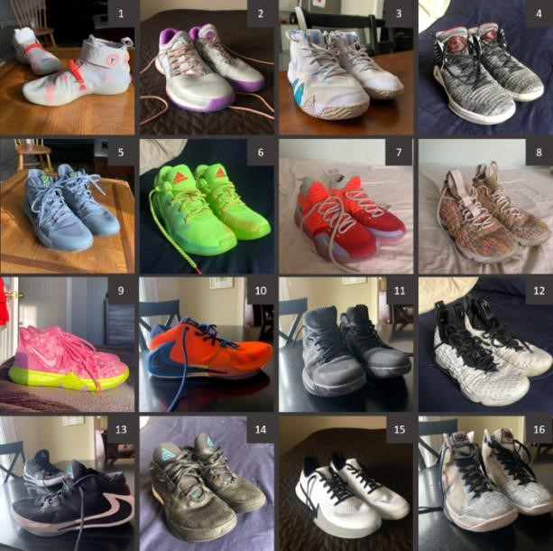
Ford & Herr, 1996; Lauer, Fisher, Zakraisek, Bejar, McCowan, Martin & Vosloo, 2018; Dickson & Pollack, 2000). Few researchers have examined footwear for female basketball players.
Methods: A mixed methods approach was used to conduct this research, combining both quantitative and qualitative modes of inquiry. The research project was done in three phases. In Phase 1 a content analysis was conducted of brand websites that feature basketball shoes for women, including Nike, Adidas, and Under Armour. The content analysis focused on both written and visual material pertaining to each brand’s basketball shoes (n=61), attributes examined included: lacing systems, materials, fit, style, color, brand, player association and available size range. Data also included photographs of the shoes and the website description. Following this, Phase 2 incorporated a personal inventory and semi-
structured interviews with 6 women in Ontario who played basketball at the college or university level. Participants provided photographs of their favourite basketball shoes and these were used during that the women selected as their favourites, functional and aesthetic preferences as well as expressive attributes and their typical shopping experiences. The data collected from Phase 1 and 2 were examined through the lens ofthe functional, expressive and aesthetic (FEA) consumer needs model by Lamb and Kallal (1992). Using data collected in Phases 1 and 2, I designed the ideal basketball shoe in Phase 3.
Results: The findings from the content analysis revealed that most basketball shoes: were made by Nike, associated with male NBA players, mid-rise, made of a textile material (vs. leather) with a foam midsole, rubber outsole with a herringbone traction pattern and offered in men’s sizing. The following themes were gathered from the interviews: shopping behavior, purchasing criteria and challenges encountered. Purchasing challenges identified indicated a lack of footwear designed specifically to fit women’s feet. Participants recounted how few women’s basketball shoes were available on brand websites. The shoes that participants identified as women’s shoes were described as ugly and lower quality. To solve their inherent purchasing challenges with the available product assortment, participants purchased children’s, youth’s or men’s shoes. This resulted in further functional and aesthetic issues for the participants. Shopping behaviors varied, some would shop online and others in store. Those who shopped in store were able to try shoes onto confirm fit. Participants who shopped online found a diversity of product assortment available. The final theme that stuck out in the interviews was purchasing criteria. Women preferred shoes with standard laces; breathable, soft and supportive uppers; rubber outsoles with good grip; colorways that had 2 or more colors; and association with professional players.
Discussion: The findings suggest there are several opportunities for improvement within the realm of women’s basketball shoes. This information is important to designers, product developers and retailers. Designers might consider expanding the range of shoe styles, studying women’s feet and applying anthropometric data to shoe design, in addition to continuing to create shoe colorways that are on trend and inclusive of different tastes. Product developers can improve the interest in their brand by incorporating unique attributes and new technologies into basketball shoes, as well as collaborating with professional female basketball players to create signature shoes. Finally, retailers might focus on the customer’s shopping experience, increasing product knowledge in advertising copy, improving in-store and online environments, and mapping out their product display.
Conclusion: This research delves into women’s basketball shoe preferences and has contributed to knowledge. The research highlights the design attributes that might be incorporated into women’s basketball shoes. We now know that basketball shoes for women don’t fit because their needs have not been assessed prior to beginning the design process. As a stop gap measure, women are purchasing men’s and children’s or youth’s basketball shoes. This practice creates irregularities in fit and problem with comfort. Women described that men’s shoes were often too wide and thus they gravitated to lacing fastening systems to achieve the desired tightness. Women are not choosing shoe styles based off the demands of the position they play, which is the conventional practice, instead they are choosing shoe styles that suit their personal needs, such as additional ankle support. This research also makes several contributions to practice. The findings are important to the way that product developers, and designers produce new basketball shoes for women and offer insights to retailers who market shoes to women to create meaningful shopping experiences.
References
Belén del Río, A., Vázquez, R., & Iglesias, V. (2001). The effects of brand associations on consumer response. The Journal of Consumer Marketing, 18(5), 410-425.
https://doi.org/10.1108/07363760110398808
Brauner, T., Zwinzscher, M., & Sterzing, T. (2012). Basketball footwear requirements are dependent on playing position. Footwear Science, 4(3), 191-198. https://doi.org/10.1080/19424280.2012.674980
Daack, C., & Senchina, D. (2014). A field study of low-top vs. mid-top vs. high-top American football cleats. Sports, 2(4), 85-98. doi:10.3390/sports2040085
Deng, X., Hui, S. K., & Hutchinson, J. W. (2010). Consumer preferences for color combinations: An empirical analysis of similarity-based color relationships. Journal of Consumer Psychology, 20(4), 476-484. https://doi.org/10.1016/j.jcps.2010.07.005
Dickson, M. A., & Pollack, A. (2000). Clothing and identity among female in-line skaters. Clothing and Textiles Research Journal, 18(2), 65-72. https://doi.org/10.1177/0887302X0001800201
Feather, B. L., Ford, S., & Herr, D. G. (1996). Female collegiate basketball players' perceptions about their bodies, garment fit and uniform design preferences. Clothing and Textiles Research
Journal, 14(1), 22-29. https://doi.org/10.1177/0887302X9601400104
Jiang, C. (2020). The effect of basketball shoe collar on ankle stability: A systematic review and metaanalysis. Physical Activity and Health, 4(1), 11-18. https://doi.org/10.5334/paah.48
Lamb, J. M., & Kallal, M. J. (1992). A conceptual framework for apparel design. Clothing and Textiles Research Journal, 10(2), 42-47. https://doi.org/10.1177/0887302X9201000207
Lauer, E. E., Zakrajsek, R. A., Fisher, L. A., Bejar, M. P., McCowan, T., Martin, S. B., & Vosloo, J.
(2018). NCAA DII female student-athletes' perceptions of their sport uniforms and body image. Journal of Sport Behavior, 41(1), 40-63.
Liu, H., Wu, Z., & Lam, W. (2017). Collar height and heel counter-stiffness for ankle stability and athletic performance in basketball. Research in Sports Medicine, 25(2), 209-218.
Luczak, T., Burch V, R. F., Smith, B., Lamberth, J., Carruth, D., Crane, C., Hoppa, M., & Burgos, B. (2020). Perception of comfort, fit, and jumping performance of elite NCAA division 1 studentathletes: The effect of basketball shoe design – part II. International Journal of Kinesiology and Sports Science, 8(3), 45-57. https://doi.org/10.7575/aiac.ijkss.v.8n.3p.45
Luczak, T., Burch, R. F., Smith, B., Lamberth, J., & Carruth, D. (2020). Jumping performance of elite NCAA division 1 student-athletes: The effect of basketball shoe design – part I. International Journal of Kinesiology and Sports Science, 8(2), 17-25.
Lynn, J., Lederman, E., & Gajderowicz, L. (2012, March 15). Over 26 Million Americans Play Basketball. Retrieved from https://www.sfia.org/press/433_Over-26-Million-Americans-PlayBasketball
Mehra, P. (2017). Factors influencing purchase behaviour of branded sports shoes. SCMS Journal of Indian Management, 14(4), 54-63.
Mirabella, L. (2018, December 16). Under Armour and other brands' basketball shoes rarely, if ever, named for female athletes. Retrieved from https://www.baltimoresun.com/business/bs-bz-womensbasketball-shoes-under-armour-20181130-story.html
Mohr, M., Trudeau, M. B., Nigg, S. R., & Nigg, B. M. (2016). Increased athletic performance in lighter basketball shoes: Shoe or psychology effect? International Journal of Sports Physiology and
Performance, 11(1), 74-79. https://doi.org/10.1123/ijspp.2014-0538
Silva, K & Madhushani, A A L & Jayalath, S. (2020). The Impact of Brand Loyalty on Customer Purchase Intention: An Empirical Study on Basketball Shoe Brands of Adidas, Nike and Puma in Asia. Journal of Physical Education and Sports Management 7(2). 17-25. DOI: 10.15640/jpesm.v7n2a3.

